MSIL CIVIL

B1

User’s Manual

***Table of Contents***

Library 4

1. Create Library 4

2. Promote Library to Active State 6

3. Import DSR 7

4. Mail Notification 9

Work Order 11

1. Create Project Template 11

2. Create Project from Global Toolbar 13

3. Create Project 15

4. Create Route Template . 18

5. Create Work Order 22

6. Add Approval Template 25

7. Import BOQ 29

8. Mail Notification 32

MBE (Measurement Book Entry) 35

1. Create MB Entry 35

2. Promote MB Entry 44

3. Promote MB Entry 47

4. Observe created Measurement Book 51

5. Reference Document 53

6. Files 56

ABME (Abstract Measurement Book Entry) 57

1. Create ABME Entry 57

2. Particulars 60

3. Advance / Recovery 64

4. Deduction (WithHeld / WithHeldRelease) 66

5. Other Deduction 68

6. ABME Approval 69

7. Notification Mail 71

8. Reference Document 75

9. Observe created Abstract MBE 80

# 

Library

[1. Create Library](#_1. Create Library)

[2. Promote Library to Active State](#_2.  Promote Library to Active State)

[3. Import DSR](#_3. Import DSR)

[4. Mail Notification](#_4. Mail Notification)

[Work Order](#_Work Order)

[1. Create Project Template](#_1. Create Project Template)

[2. Create Project from Global Toolbar](#_2. Create Project from Global Toolbar)

[3. Create Project](#_3. Create Project)

[4. Create Route Template .](#_4. Create Route Template .)

[5. Create Work Order](#_5. Create Work Order)

[6. Add Approval Template](#_6.  Add Approval Template)

[7. Import BOQ](#_7.   Import BOQ)

[8. Mail Notification](#_8. Mail Notification)

[MBE (Measurement Book Entry)](#_MBE (Measurement Book Entry))

[1. Create MB Entry](#_1. Create MB Entry)

[2. Promote MB Entry](#_2. Promote MB Entry)

[3. Notification Mail](#_3. Notification Mail)

[4. Observe created Measurement Book](#_4. Observe created Measurement Book)

[5. Reference Document](#_5. Reference Document)

[6. Files](#_6. Files)

[ABME (Abstract Measurement Book Entry)](#_ABME (Abstract Measurement Book Entry))

[1. Create ABME Entry](#_1. Create ABME Entry)

[2. Particulars](#_2.  Particulars)

[3. Advance / Recovery](#_3.  Advance / Recovery)

[4. Deduction (WithHeld / WithHeldRelease)](#_4.  Deduction (WithHeld / WithHeldRelease))

[5. Other Deduction](#_5.  Other Deduction)

[6. ABME Approval](#_6.  ABME Approval)

[7. Notification Mail](#_7.  Notification Mail)

[8. Reference Document](#_8.  Reference Document)

[9. Observe created Abstract MBE](#_9. Observe created Abstract MBE)

# Library

# 1. Create Library

To start , Login with Librarian(Project User) role , an create the Library in ENOVIA system.

**Login as Librarian/ Project User**

To Create Library Follow these Steps :-

1. Login to with your user-name and password. Enovia home page appears to user .
2. Navigation:- from compass Click on North Quadrant of Compass Classify and Reuse App (A)Click on Libraries(B)

A.

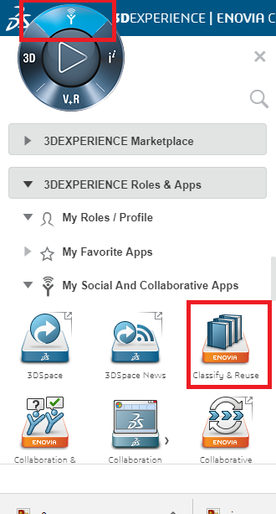 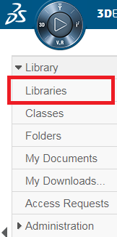

1. Libraries page should open. Click on Action Menu from table page

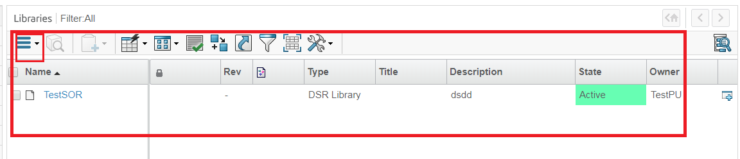

1. Navigation:- Libraries page Click on Action Menu

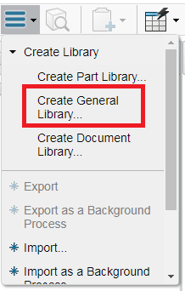

1. Navigation:- Click on Create General Library . This should display Create New Library Slide-in Page, for Creating New Library.

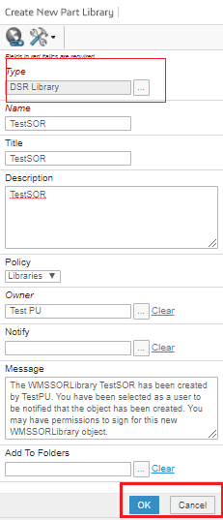

Select Type as DSR Library by clicking on chooser.

1. Enter details required and click on **Ok button**. A New Library will be created .

# 2. Promote Library to Active State

1. From the Libraries page , Click on the Library name , from name column, 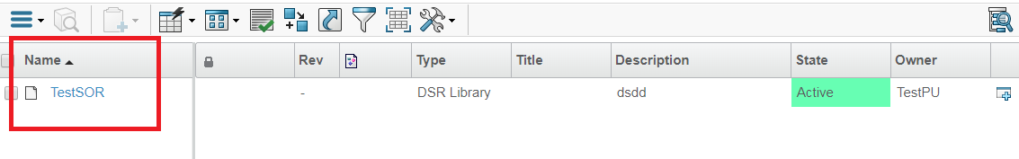

1. Navigation:- From Category MenuClick On Life-cycle

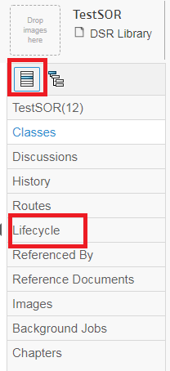

1. Click on Promotion Link

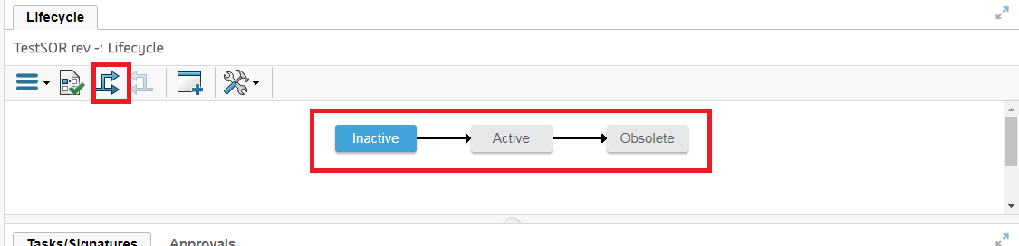

.

1. Promoting the life-cycle from **Inactive** to **Active state.**

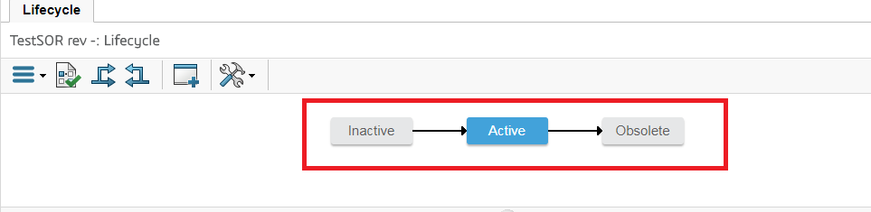

# 3. Import DSR

1. Navigation :- Click on Libraries from Category Menu , Click on Chapter, Chapter page will open ,

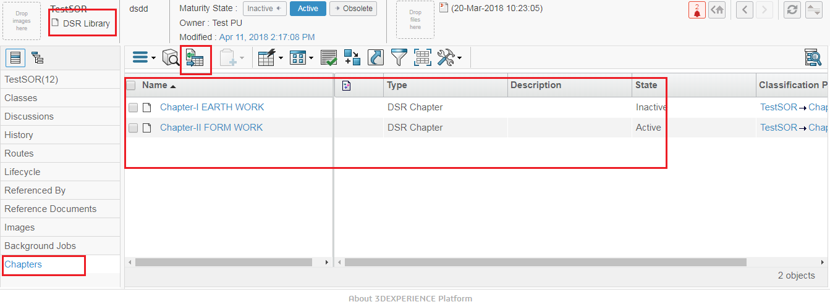

1. From Action toolbar menu Click on Import 18 , this should display Slide-In Form Page to Import DSR Item in Chapter

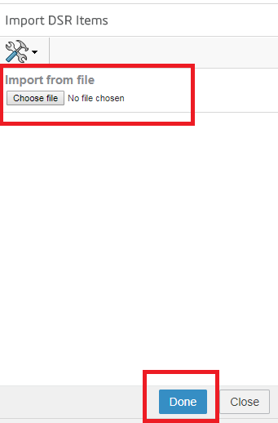

1. Click on Choose file buttonSelect DSR Template Click On DoneA pop up message will display

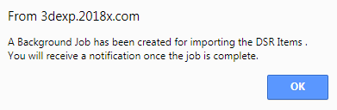

1. Click on OK on Pop-up ,this will Import the file and display in chapter table as:-

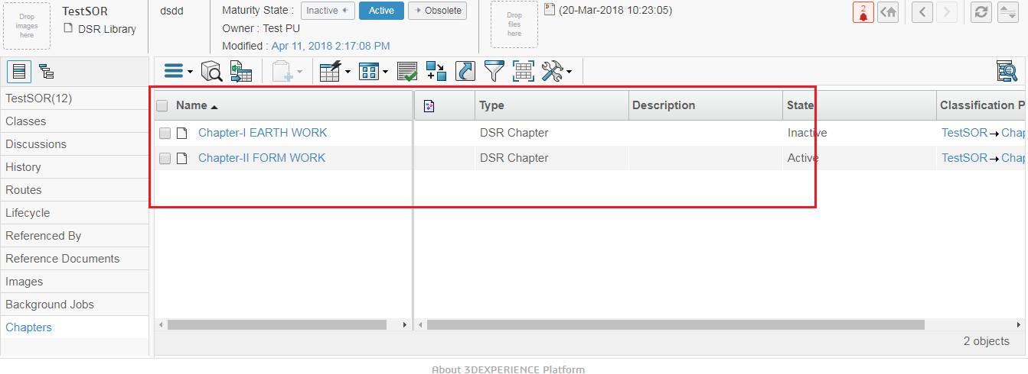

1. Click on Name of DSR Chapter Imported from name column, it will open DSR list of DSR items imported .

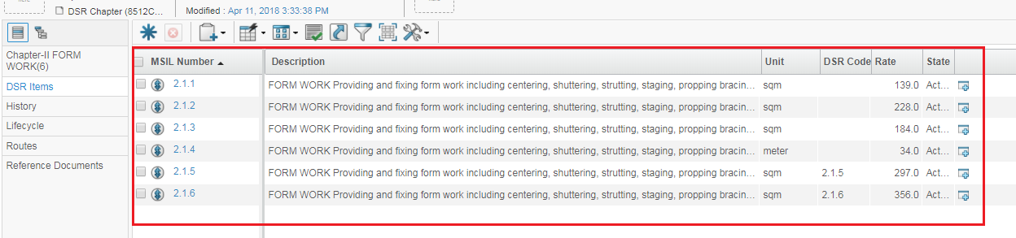

# 4. Mail Notification

A Mail Notification will be send for Importing the DSR item and a Job will be created.

1. Navigation : from global Toolbar menuClick on user icon Click on Message

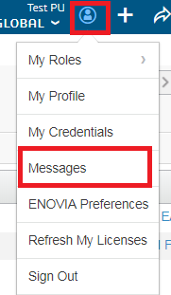

1. A message page will Open and will show the Notification received. Click on unread mail received , on subject “ Importing DSR Items Successful”.

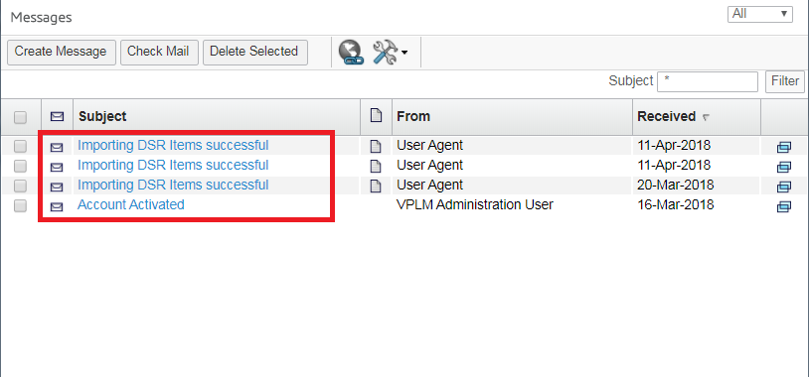

1. Mail Properties page will open which will show the Mail contents,Click link on Job at Message field

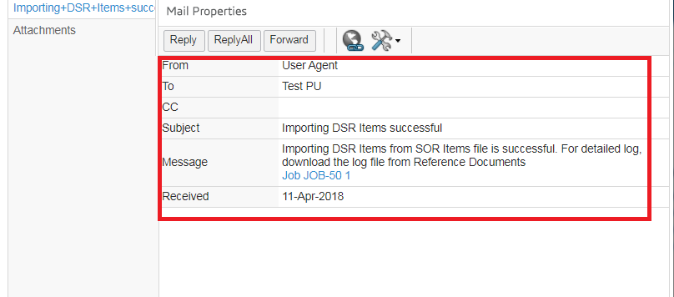

1. Monitor Progress Page show Succeeded. Which mean Importing is done and DSR is created successfully.

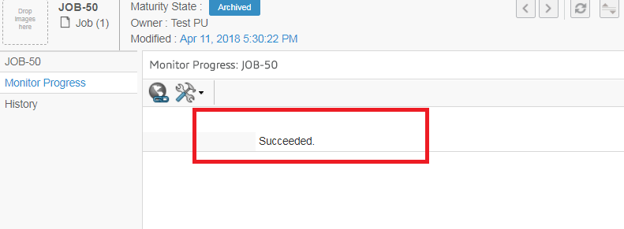

# Work Order

# Work Order should be created under the Project, and Project will be created only through the Template. So we will have to created the Project Template.

# 1. Create Project Template

To start , Login with Project Lead (DPM role ), to create the Project template .

**Login as Project Lead / DPM role**

To Create Project Template Follow these Steps :-

1. Login to with your user-name and password. Enovia home page appears to user .
2. Navigation:- from compass Click on Social and Collaborative Apps Project Management
3. 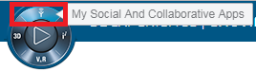 (B) 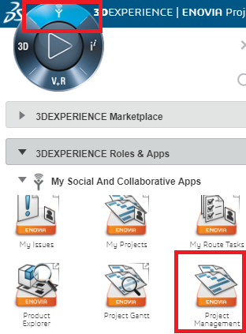
4. Navigation :- from the Category Menu Click on Project Template .

Which will open the Project Template Page . With Action Toolbar Menu have icons Links for Create ,Remove selected (disable), Clone/copy(disable).

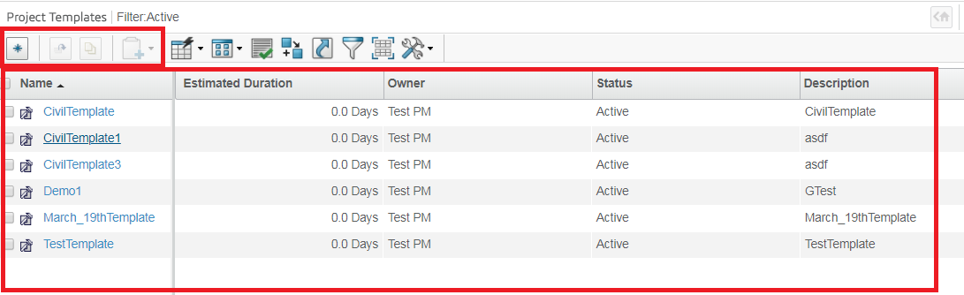

1. Click on Create New Project Template Link from Action toolbar menu 7. A Slide-In form Page will open for creating Project Template .

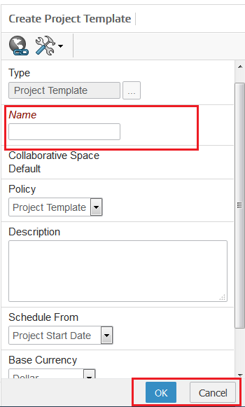

Name for Project Template

1. Enter All Fields and Click on **Ok** button , will Create a new Project Template and visible to the user in a table .



# 2. Create Project from Global Toolbar

Create Project Explain the Process for Project Space , and we should create Project Space Only through the Project Template given. Project Lead (DPM role )

To start , Login with Project Lead (DPM role ), to create the Project template .

**Login as Project Lead / DPM role**

To create Project from global toolbar Follow these Steps :-

1. Login to with your user-name and password. Enovia home page appears to user .
2. Navigation: from the Global-tool barClick on Add iconClick on ProgramClick on Create Project .

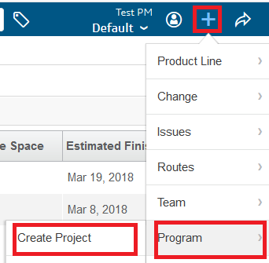

1. A New Form page will open with the Fields , to create the project . We will create the Project only with the given template . No other way excepted.

Project should be Created only with Template ,

Will select from chooser

1. Enter All Fields and Click on **OK** button , will Create a new Project . Project Template filed Must be there as we are created Project with Template .

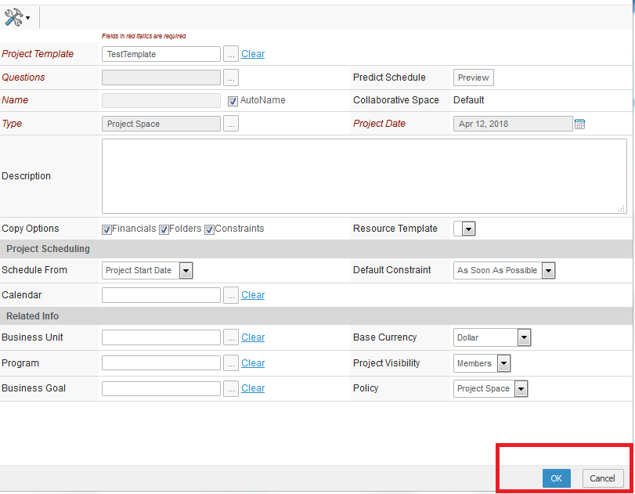

1. Created Project will display at Project page , with Link on every Project Name .

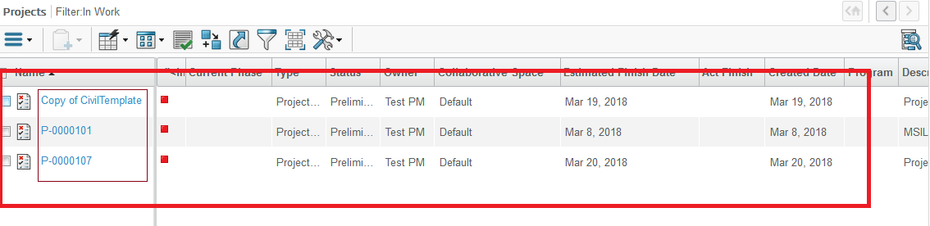

# 3. Create Project

Create Project Explain the Process for Project Space , and we should create Project Space Only through the Project Template given. Project Lead (DPM role )

To start , Login with Project Lead (DPM role ), to create the Project template .

**Login as Project Lead / DPM role**

To create Project Follow these Steps :-

1. Login to with your user-name and password. Enovia home page appears to user .

2. Navigation: - from compass Click on North Quadrant of Compass Project Management from Category menu click on Project .



1. from Category menu click on Project this will open the Project page .

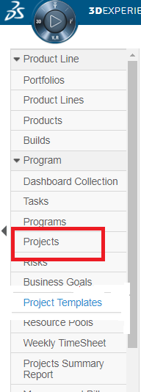

4. Project page will be open in a table . Which should show the no. Of project created , With Action-toolbar menu in a table.



1. Navigation:- Click on Action-toolbar menu Click on Create Project .

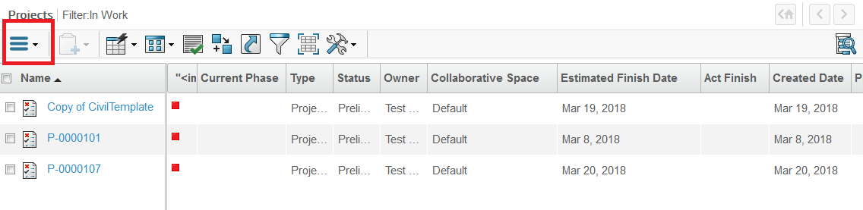

1. A New Form page will open with the Fields , to create the project . will create the Project only with the given template by selecting the template from form page. No other way excepted.



1. Enter All Fields and Click on **OK** button , will Create a new Project . Project Template filed Must be there as we are created Project with Template Only.
2. Created Project will display at Project page , with Link on every Project Name .



# 4. Create Route Template .

Project templates will maintain the generic set of works activities applicable to any project based on complexity and type of project.

Project templates contain commonly re-used components of projects such as folders, bookmarks, and tasks. These templates provide the ability to establish a common structure from which projects can be created. This common structure makes it easier for Project Leads to create projects and it lets your organization standardize on improvements and best practices.

**Login as Project Lead / DPM role**

To create Route Template Follow these Steps :-

1. Login to with your user-name and password. Enovia home page appears to user .

2. Navigation :- from Compass Click on North Quadrant of Compass Collaboration and Approval from Category menu click on Route(B.) Click on created Route Template

A.) B)

A.)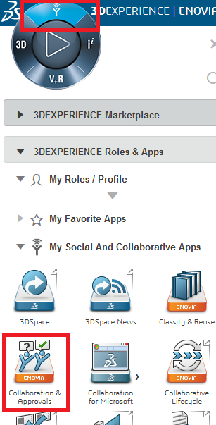 >> B.) 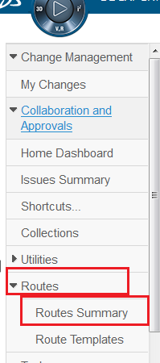

3. Route Template page should be open with create Route Template and Delete icon link should be there in Action menu and route should be display in Table,

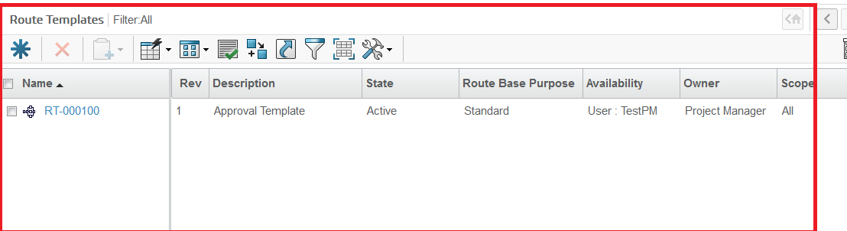

1. From Action menu click on the Create New , A form page should open , Enter

All information on step 1 of 4 : specific detail page and click on Next which will move to next page

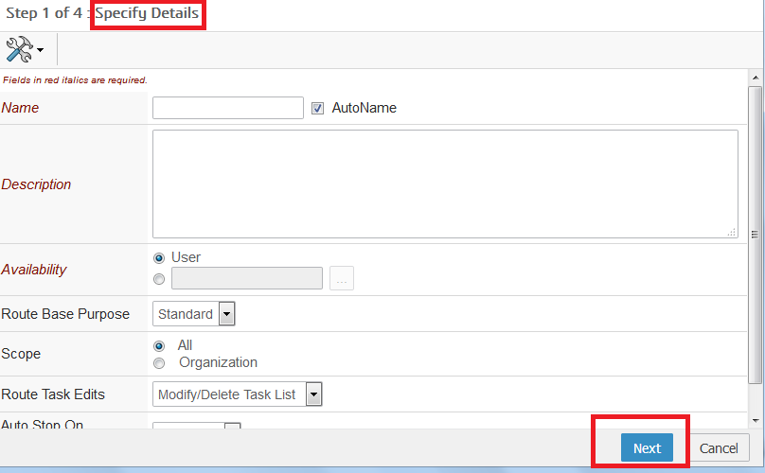

1. Step 2 of 4 : should be select Route Template Member pageClick on Action select Role , role page open Add Role from Role page click on Done Selected Role should be display in Select Route Template page .

Click on Next . To move onto next page .

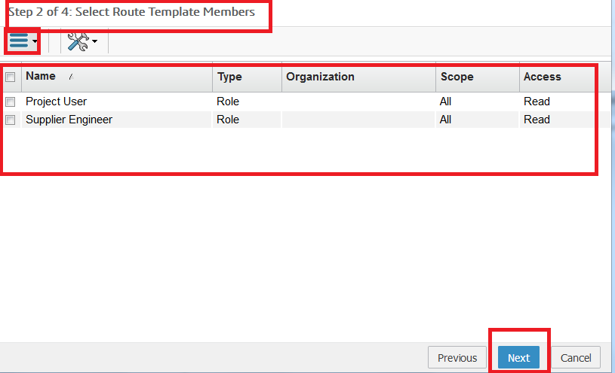

1. Step 3 of 4 : Define Route Task page should be opened . Enter All the mandatory details and click on Next which should moved to next page .

And 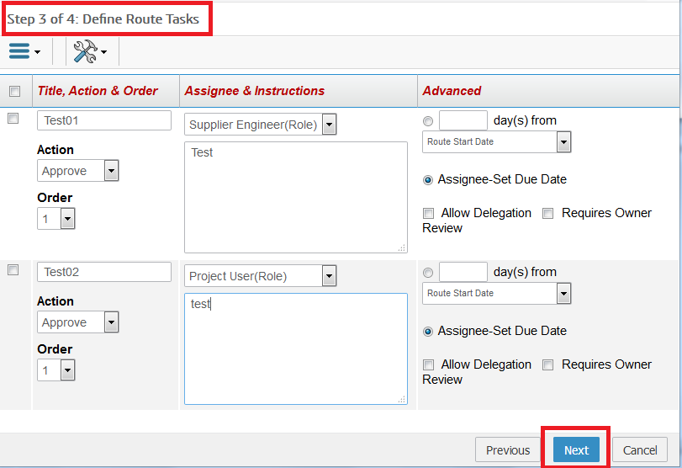

7. Step 4 of 4 : Action Required page should be open whatever we have entered in above (6th step) should show here .Click on Done

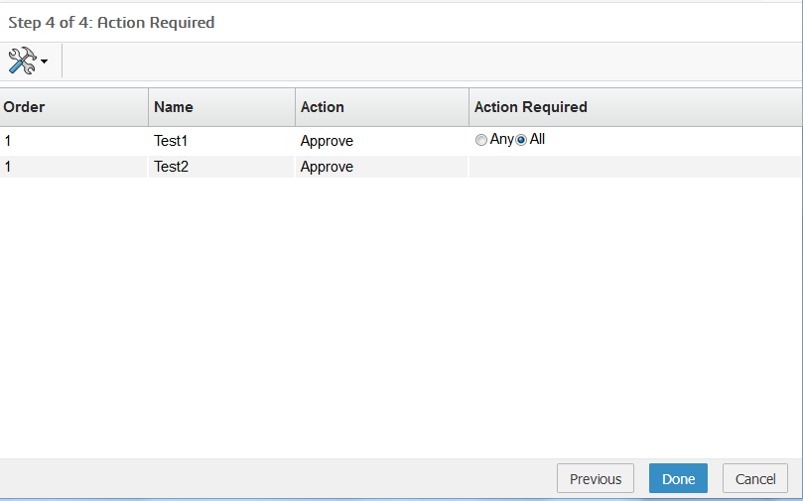

1. Should create the Route Template and Route Template property page should be visible. State should be Inactive when Route Template created

When Route Created it should be in Inactive State create

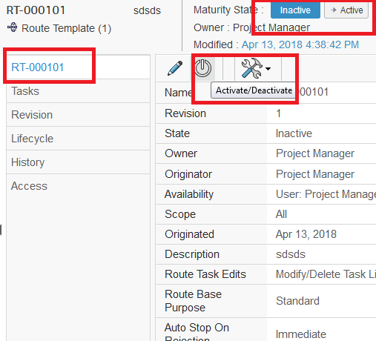

1. Click on Active / Deactivate button link on Action menu to Activate the Route Template .

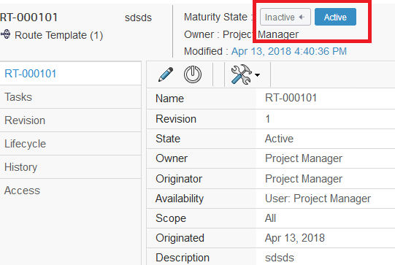

# 5. Create Work Order

Work order Command will Under the category menu of Project . and we should create Project Space Only through the Project Template given. Project Lead (DPM role )

To start , Login with Project Lead (DPM role ), to create the Project template .

**Login as Project Lead / DPM role**

To create Work Order Follow these Steps :-

1. Login to with your user-name and password. Enovia home page appears to user .

2. Navigation :- from Compass Click on North Quadrant of Compass Project Management from Category menu click on Project Click on created Project Name (Link on project Name )

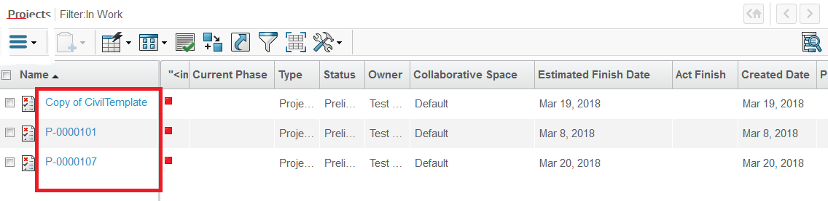

1. Project Page should be open while clicking on the Project name from Name column.

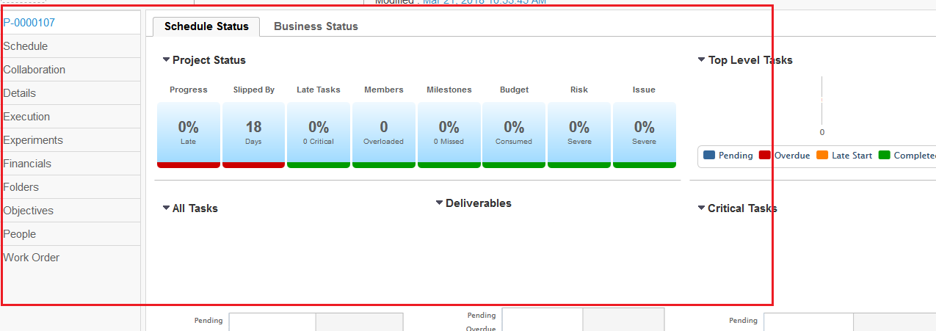

4. From the Category Menu from Project , click on Work Order

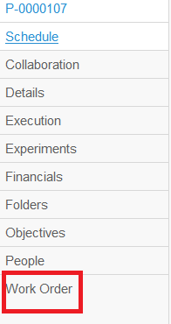

1. Work Order Page should be open , if Work order is Already created it should display in work order table page.

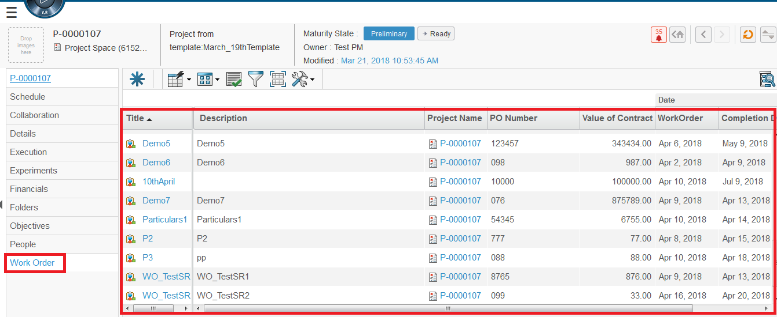

1. Click on Add work Order icon from Action menu .

Create New Link

1. Add Work Order Details Form page will open , to create the Work Order , 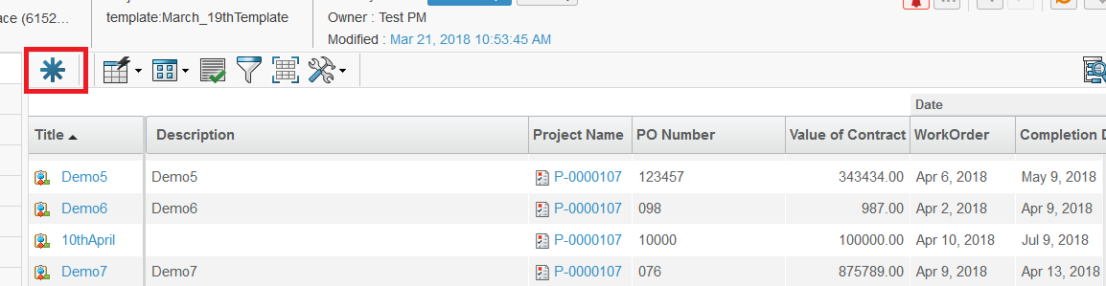Under the Project .

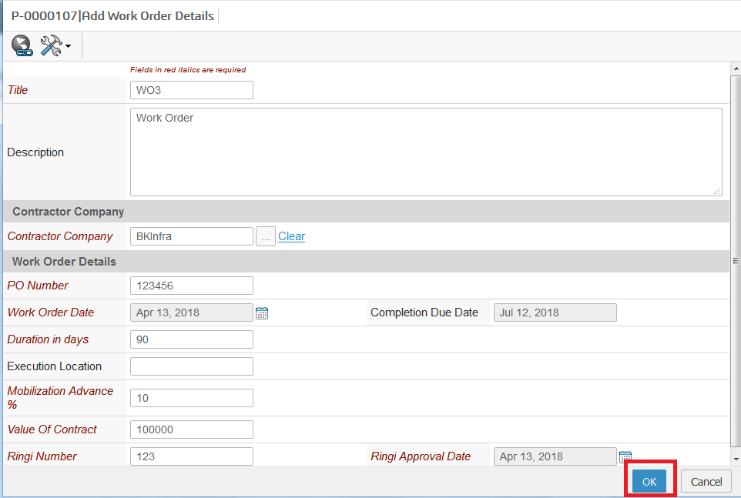

Title for work Order

Contractor Compny name , supplier should be added

1. Enter All Fields and Click on **OK** button , will Create a new work Order , under Project Space and created work order should be visible at the Work order table page , created work order (title) will have link on it. Work order created will in create state when it created.

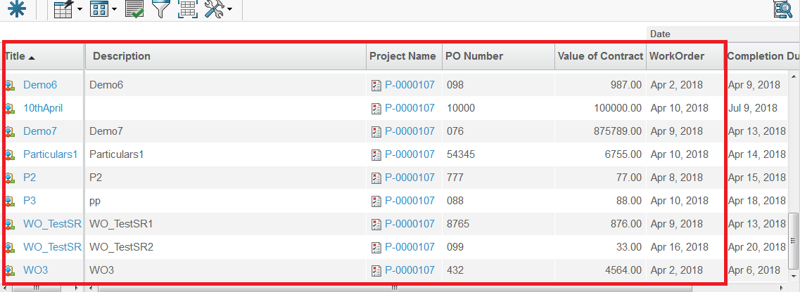

# 6. Add Approval Template

Add Approval Template should be added under Work order . Approval Template is just a Route Template which are created and move to Active state.

To start , Login with Project Lead (DPM role ), to Add Approval Template .

**Login as Project Lead / DPM role**

To Project Template Follow these Steps :-

1. Login to with your user-name and password. Enovia home page appears to user .

2. Navigation :- Click on North Quadrant of CompassProject Management from Category menu click on ProjectClick on created Project Name (Link on project Name )From the Category Menu from Project , click on Work Order.



1. Click on the Work Order from the Title column from Work Order Page .

I.e work order we have created click on it a link should be there at title of each Work Order . Work Order Property page should open.

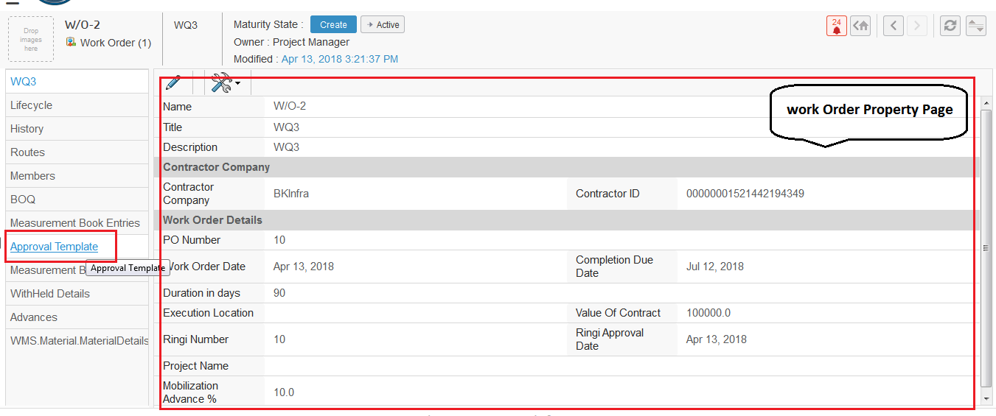

1. From property page , on Category menu

click on Approval Template. Approval Template Page should open. With Action menu have Add Approval Template Link , Delete Link And Edit All link

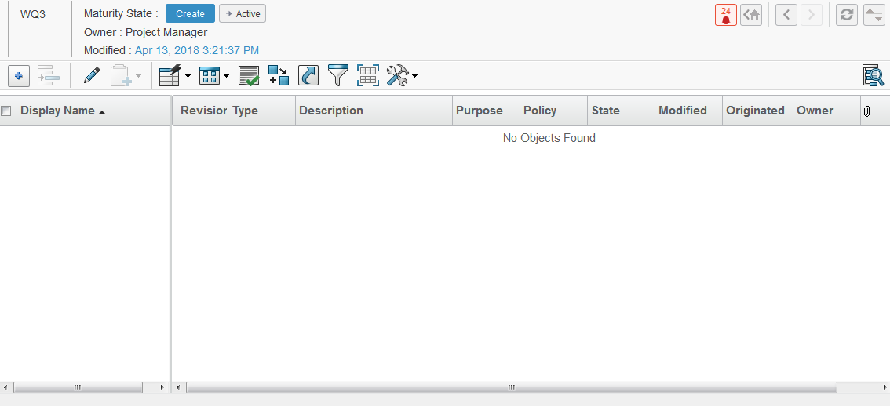

5. Click on Add Approval Link from Action Menu 36 .

Search Page should be open with List of Approval template select template from the search page , and click on Submit on Search page .

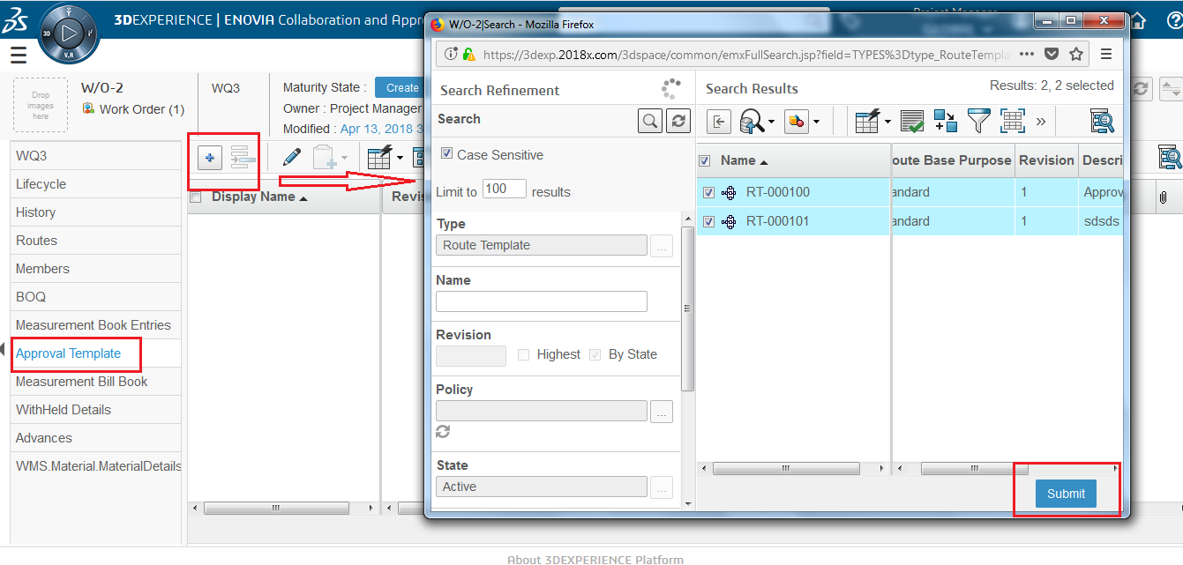

1. Selected template will be visible at the Approval Template Page

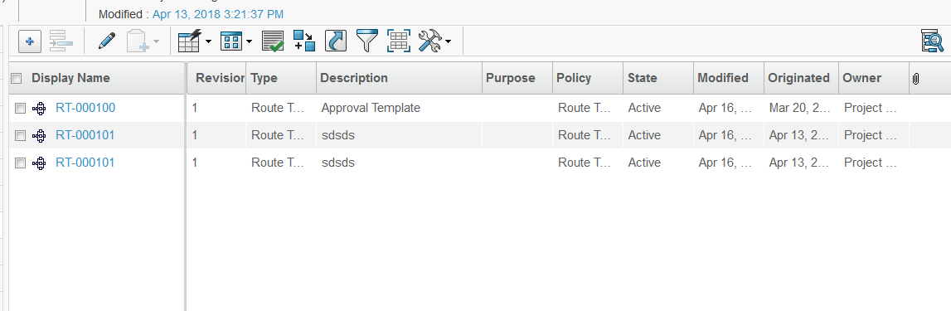

At least 3 Approval template must be Added

1. Now Add Purpose to Route Template , in Table at Purpose column.
2. Click on Enable Edit Button , page will be visible at Edit Mode with save and Cancel button . And Select Purpose from the Drop-down box

List

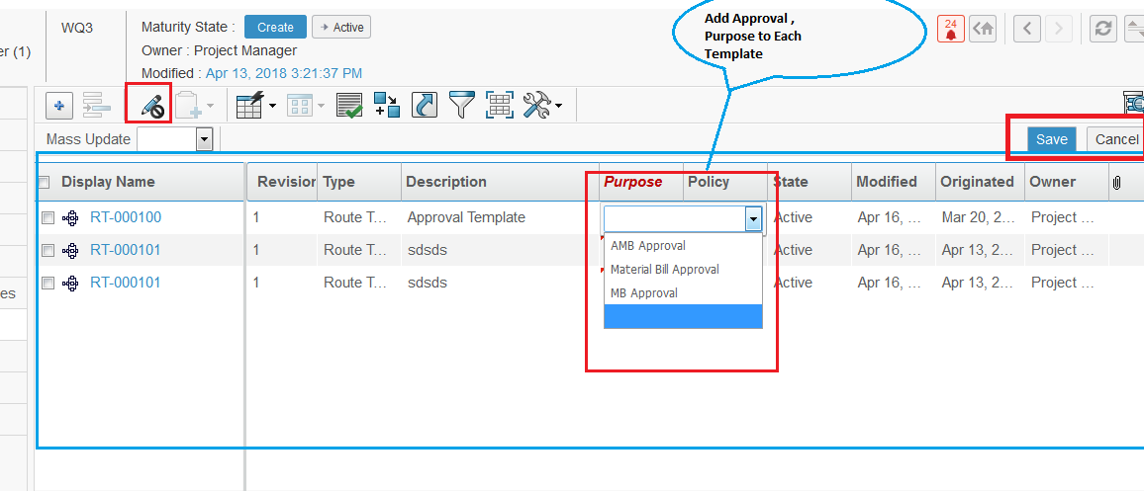

1. Enter All the Field in Purpose column. And click on Save , Entered Value will be saved in a table .

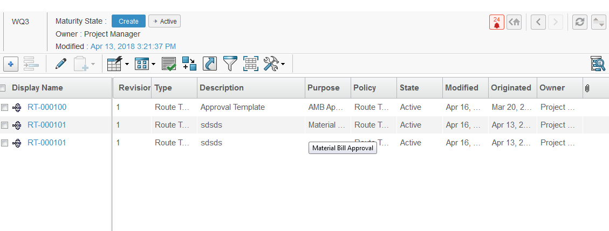

10. At least 3 Approval Template must be added and , all three must be there , then only promotion can done . We can Add multiple Template but these three must be there , AMB Approval / MB Approval / Material Bill Approval if Any of there is missing pop-up page will show with message .

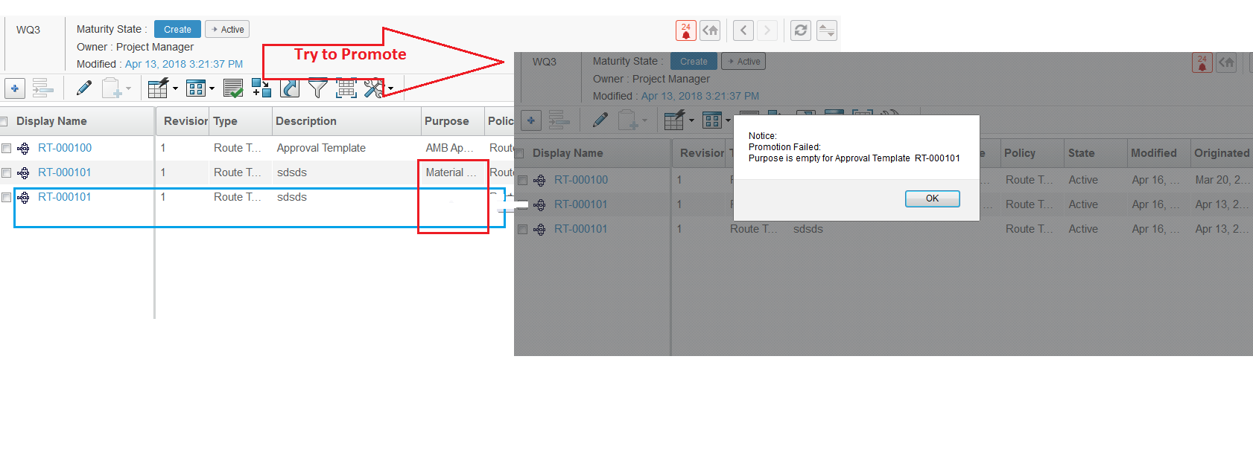

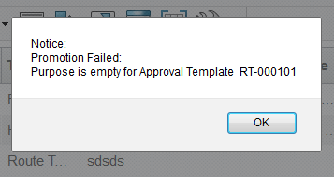

1. Enter All the Purpose in Route Column and Try to Promote . It will Promote to Active State . All condition satisfied.

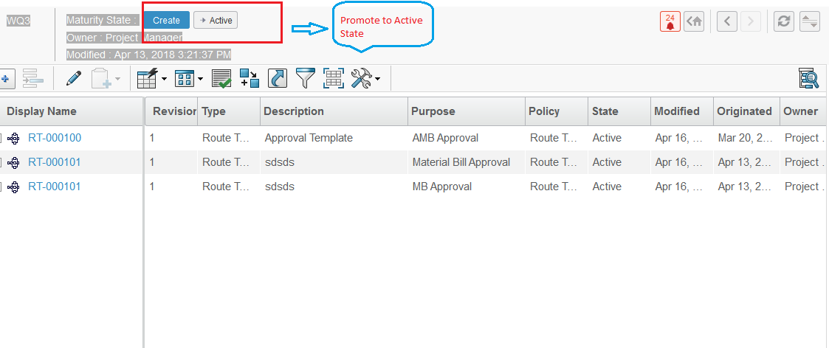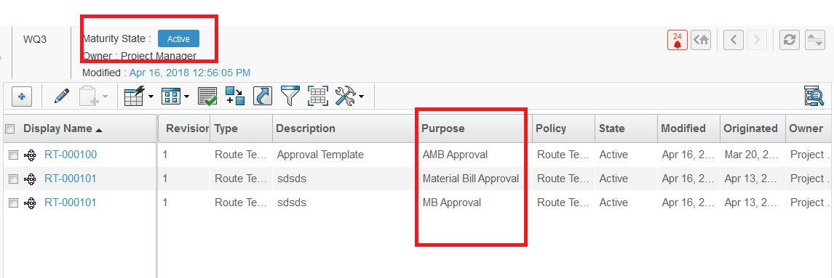

# 7. Import BOQ

BOQ is bill of quantity from the awarded contract which is basically list of items required for the works execution. Items in the BOQ are from the applicable SOR library with which the contract is awarded.

**Import BOQ from excel.**

**Login as Project Lead / DPM role**

To Project Template Follow these Steps :-

1. Login to with your user-name and password. Enovia home page appears to user .

2. Navigation :- Click on North Quadrant of Compass Project Management from Category menu click on Project Click on created Project Name (Link on project Name ) From the Category Menu from Project , click on Work Order.

1. From The Category Menu of Work Order Click on BQO , BQO page will open , with Import DSR Item icon Link on Action Menu

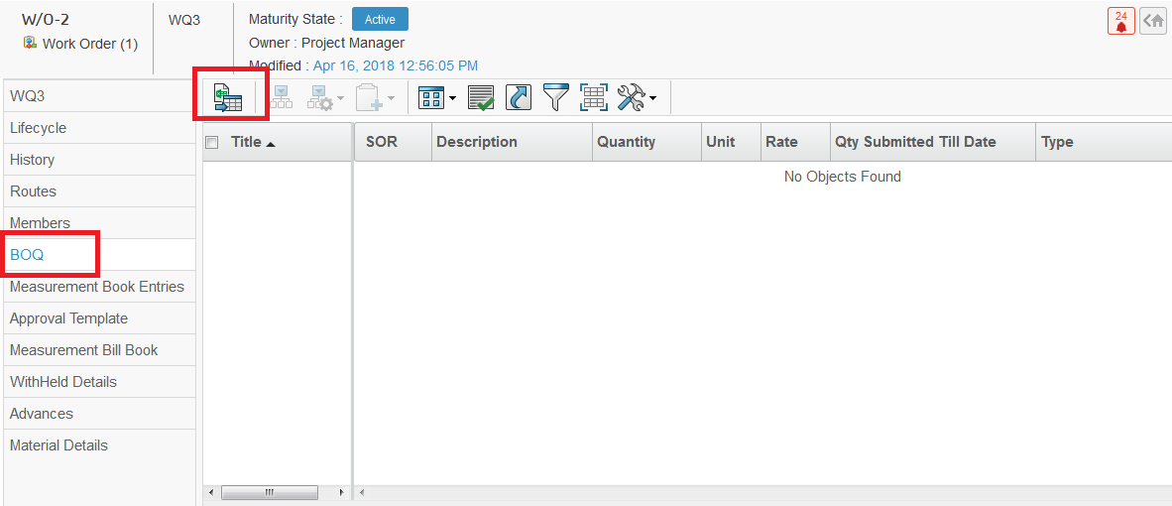

Import DSR Item icon

1. Click On Import DSR Item icon on Action Menu . A Slide In Imported Item Page form Page will open.

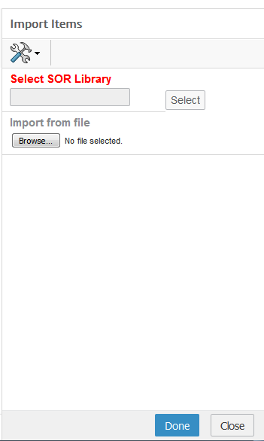

1. Click on Select button on Imported Item , Search page will open with DSR Library . Select DSR Library from the List and click on Submit Button. Selected Library will be visible at Textbook.

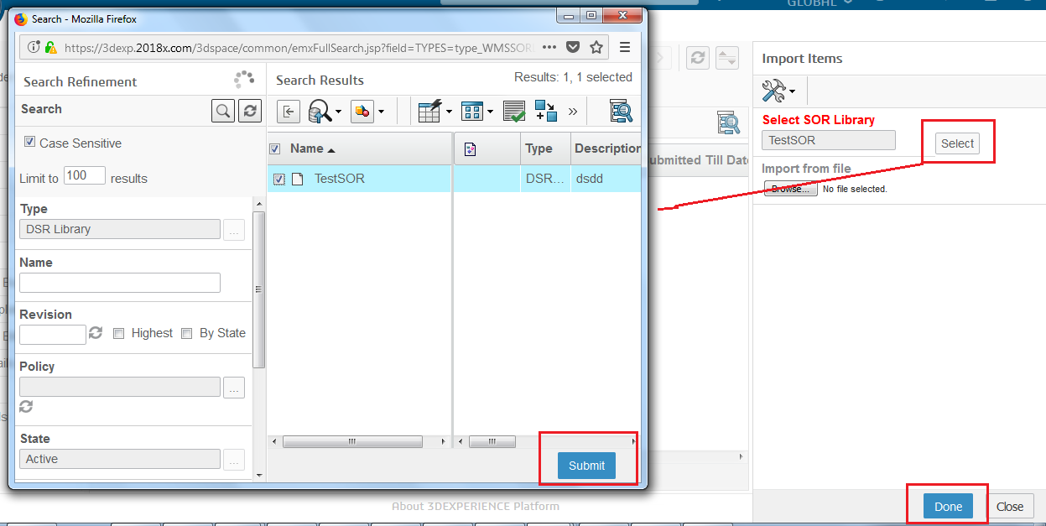

1. Click on the Browse button On Imported Item Slide In Page . And Select

Excel file and click on Done button , Only excel file it will take. For Import.

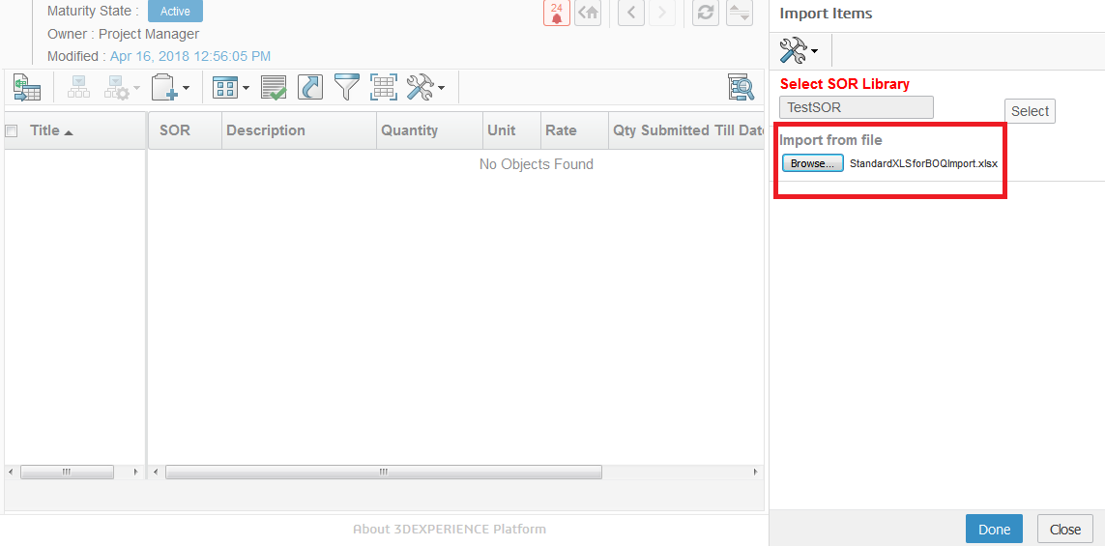

Click on Done

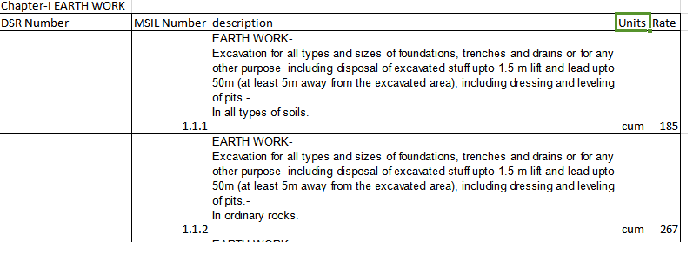

Select the Template (excel file )from Browse button

1. On Clicking on Done , a pop-up message will populate , click on OK on pop-up message and a BOQ is imported and visible in Table .

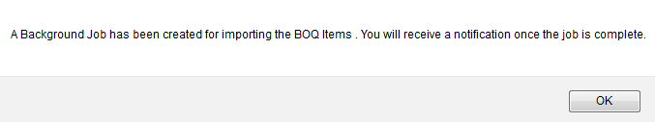

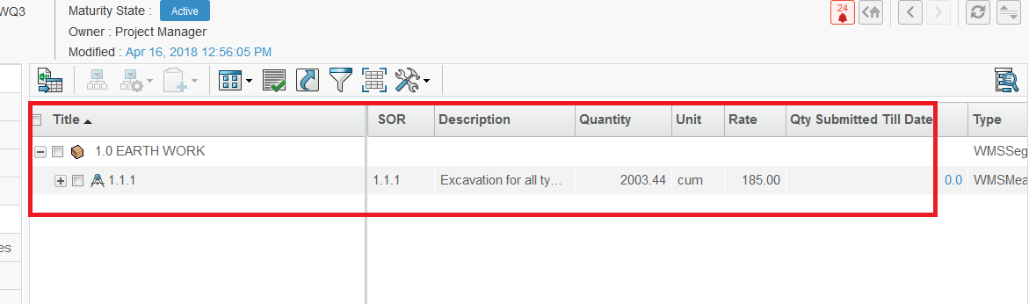

BOQ is Imported and will be visible at BOQ table

# 8. Mail Notification

A Mail Notification will be send for Importing the BOQ item and a Job will be created.

1. Navigation : from global Toolbar menu Click on user icon Click on Message



2. A message page will Open and will show the Notification received. Click on unread mail received , on subject “ Importing BOQ Items Successful”.



3. Mail Properties page will open which will show the Mail contents, Click link on Job at Message field



4. Monitor Progress Page show Succeeded. Which mean Importing is done and BOQ is Imported successfully.



# MBE (Measurement Book Entry)

# 1. Create MB Entry

Monitor Once BOQ is created . Project Lead / DPM rolecan make this work order active . It makes this work order visible to Suppliers Representative.

Measurement Book is record book in which measurement details of work done for contract are maintained.

Measurement books are created in with Supplier Role under work order by Project Lead.

**Login as Supplier Representative**

To create Measurement Book Follow these Steps :-

1. Login to with your user-name and password. Enovia home page appears to user .

2. Navigation :-from Global Tool bar menu Click on Capture Click on Work Order Management Create MB Entry

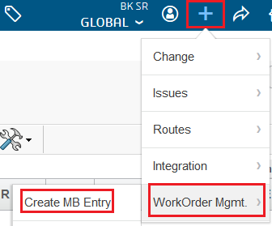

1. MB Entry Slide-In form Page will open with Ok and Cancel button.

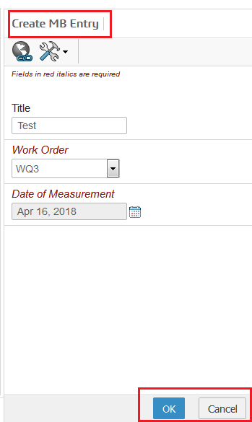

Work order drop down box will have list of work order which move to Active State, will be visible here

4. Measurement Book created and by default from the category menu Measurement page will be selected. Action Menu have , Action commands and **Add Measurement icon** link and **Download link icon** will be there

Measurement book created

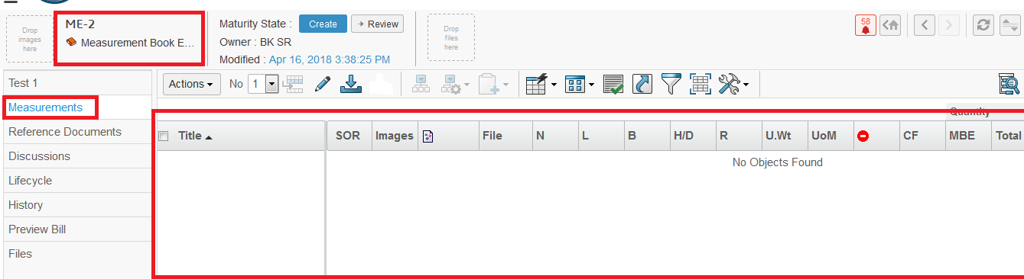

By default Measurement from category menu selected

1. From the action menu click On action Command. Click on Add Existing Command

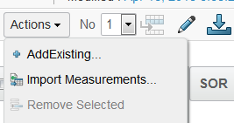

1. A search Page will be opened with, **Submit** button and list of Measurement will be there , select Measurements from the list and Click on Submit. (User can select single and Multiple from the list ) .

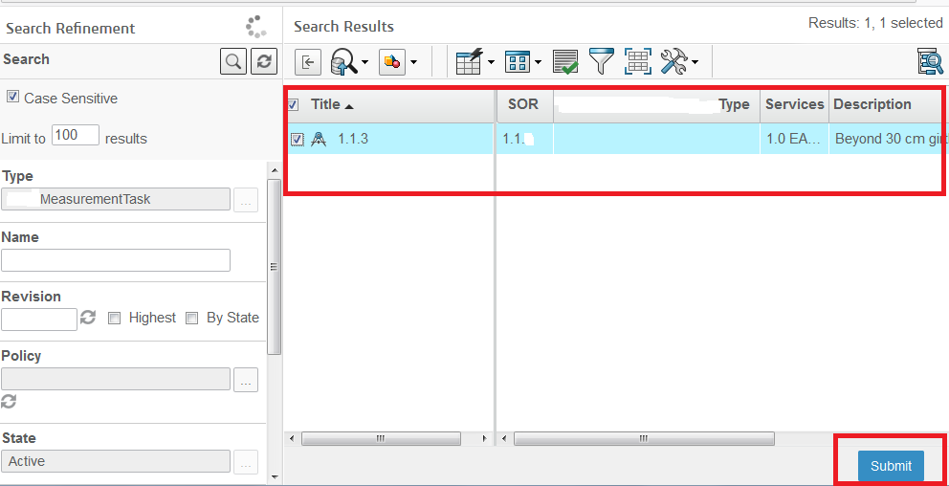

Measurement Task

1. Selected BOQ item added to measurement Entry to take measurement .

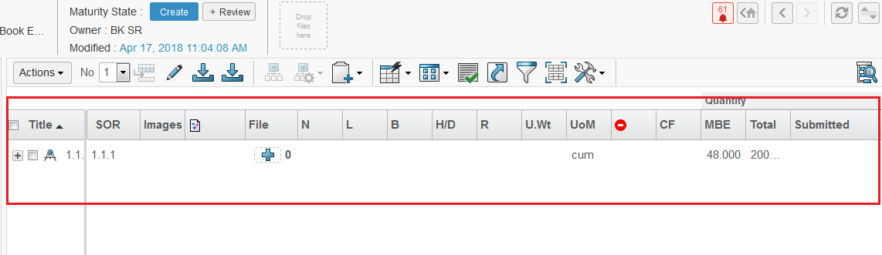

Import Measurement

1. Supplier Representative can also create measurements using excel import option. This allows to import measurements against BOQ items using excel in predefined format. Click on import Measurements from Action menu , Import Measurements page will open ,
2. Click on Browse button to search for excel file and Click on Done .

Click on Browse button to search excel file to import

 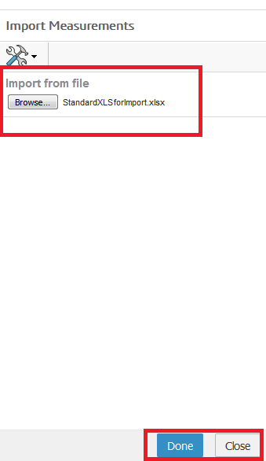

Excel File format to import



1. A pop-up message will Come click on OK and Selected file will be added

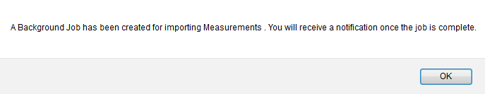

Import is done and file is added in table.

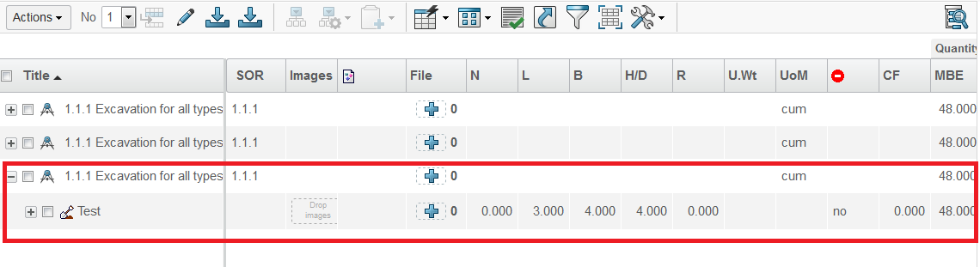

Remove Measurement

1. Supplier Representative can also Remove measurements the table.

Select Measurements from Table Click on Action Menu Click on Remove.

1. Selected Item will be removed from table

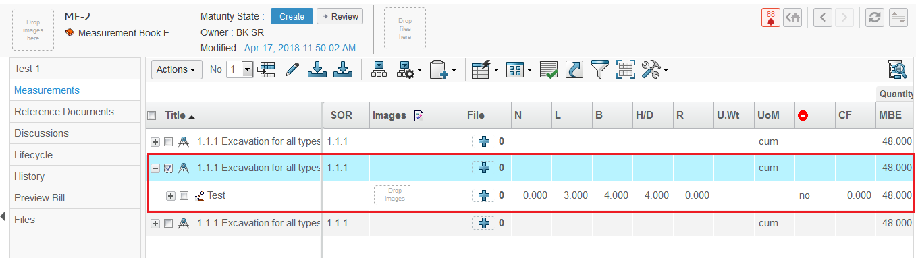

Select measurement to delete

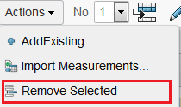

Selected item will be removed

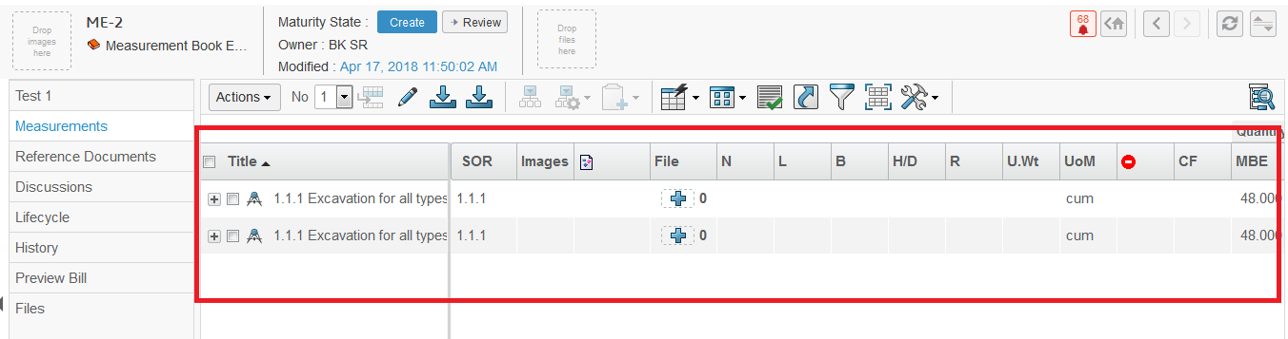

Remove Measurement

13 . Supplier Representative can also Remove measurements the table.

Navigation :- Select Measurements from Table >> Select No. From dropdown in Action toolbar >> On Action toolbar click on Add Measurement icon >>

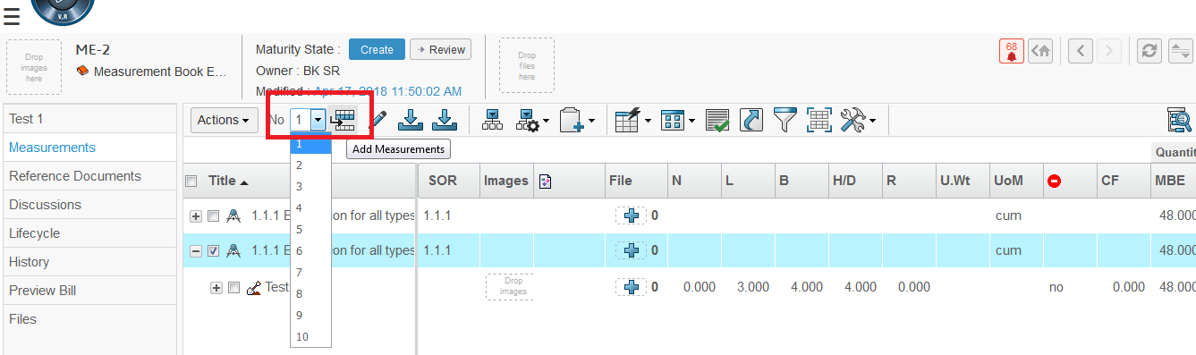

3. Click on icon , will add items at measurement

2. Select No. From drop down list , how many Measurement task will want to add

1. Select Measurements at which will want to add

1. Measurement task will added under the selected items, as one No. Selected it will add only one item.

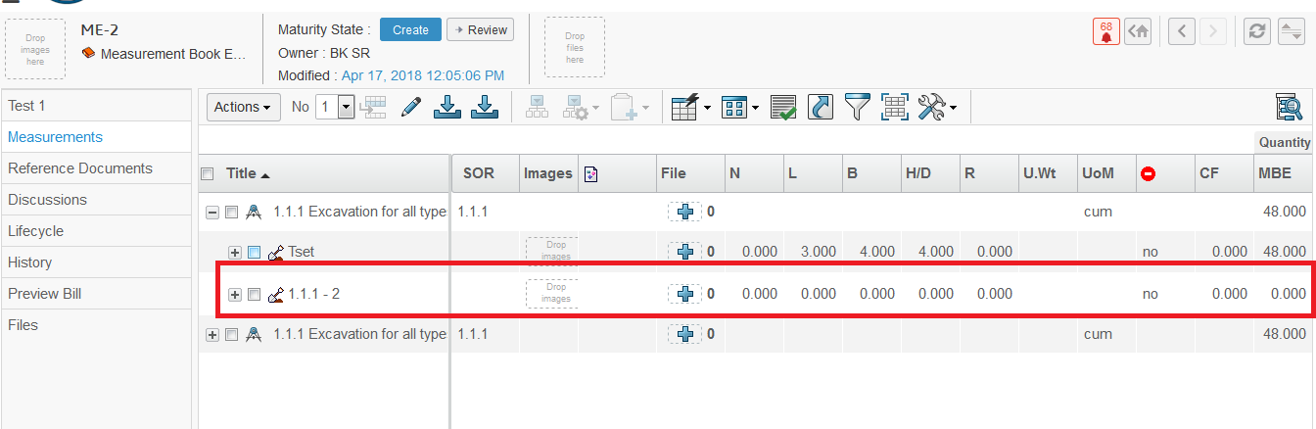

1. Click on 21 from action menu . It will download and give Excel file format to import .
2. From the Action menu , click on Enable Edit link 22 , page will view

in Edit mode 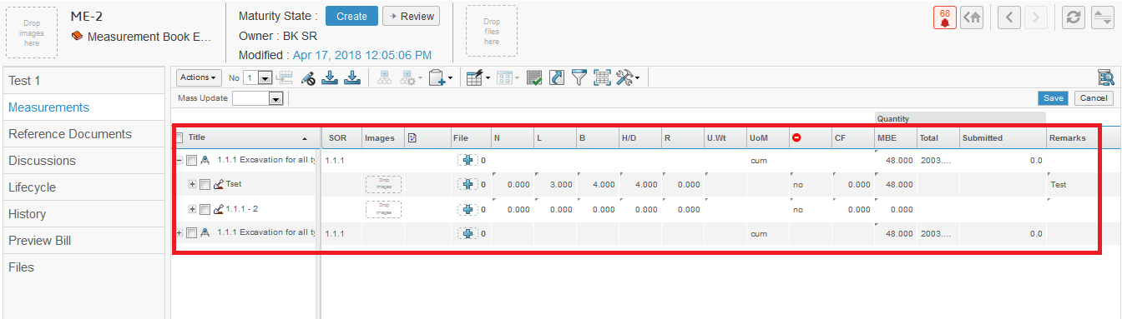

Following fields are

|  |  |  |  |  |  |
| --- | --- | --- | --- | --- | --- |
| Title | : | This is title/description of the measurement entry | | |  |
| SOR | : | SOR item number | | |  |
| Images | : | Progress images | | |  |
| File | : | Reference files | | |  |
|  | : | GPS coordinates of the image for navigation on maps | | | Supplier Representative |
| N | : | Number | |  |
|  |  |
| L | : | Length | |  |  |
| B | : | Breadth | |  |  |
| H/D | : | Height/Depth | |  |  |
| R | : | Radius | |  |  |
| U.Wt | : | Unit weight | |  |  |
| CF | : | Coefficient Factor | | |  |
| 24 | : | Deduction Yes/No (Quantity is –ve if selected Yes) | | |  |
| UoM | : | Unit of Measure | | | |
| MBE | : | Total MBE quantity recorded for the entry | | |  |
| Total | : | Total Quantity | | |  |
| Submitted | : | Total submitted Measurement entries against item | | |  |
| Remarks | : | SE can put relevant remarks for the measurement entry if required | | |  |
|  | | |  |  | |

1. Supplier Representative can record measurements against each item added to measurement entry. After adding measurements with required field values Supplier Representative can save the Measurement Entry, to edit or update later. Supplier Representative can edit measurements till the measurement entry is in “Create” state, and not allowed to edit once it is submitted.

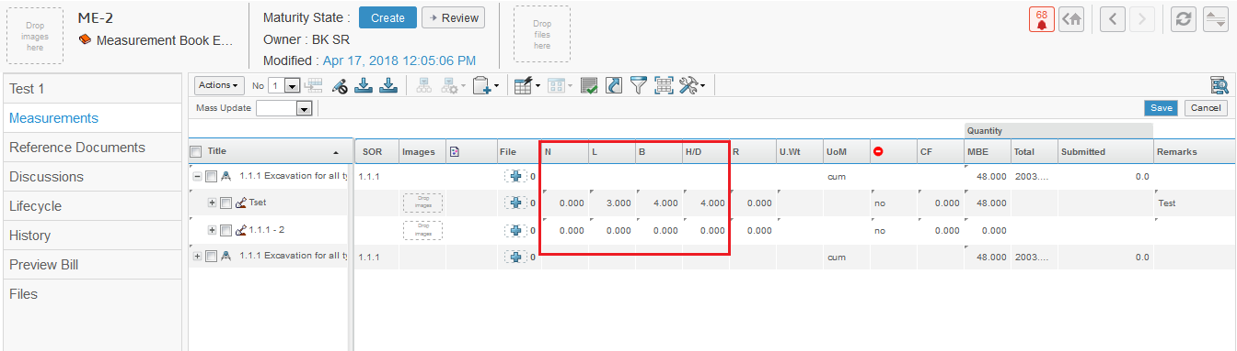

Enter measurement value in relevant field like N , L , B , H/D etc...

If deduction will Yes -ve MBE value

And Enter all the fields and click on Save button.

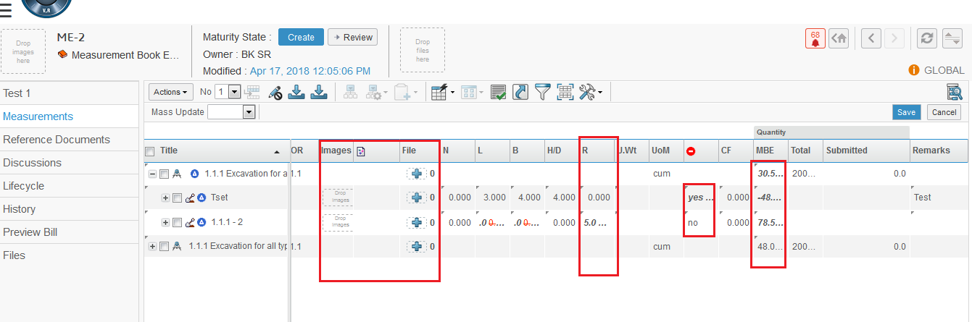

If deduction will No +ve MBE value

MBE quantity is rolled up from measurements under the item

Select YES if measurement being taken is deduction. This makes measurement quantity MBE -ve

Enter measurement value in relevant field Radius , we can not put value R with N*L*B , either any N*L*B or R will be there

Drag and drop image to the measurement

1. If Measurement Quantity is Exceeding the Total Quantity the a pop-up message will show . MBE total value will be less than Total value.

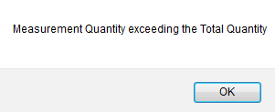

Preview Bill Measurement category Menu

1. From the Category Menu click on Preview Bill . Preview page will open , this page will helps Supplier Representative to understand financial progress of the work with reference to physical progress in specific measurement entry
2. Supplier Representative can see total value of Work done in Measurement Entry.

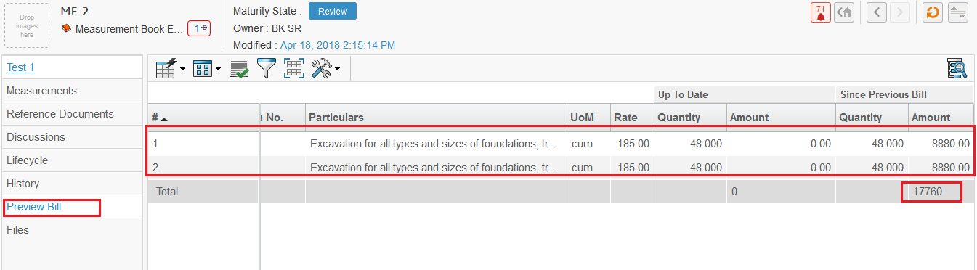

total value of Work done in Measurement Entry

# 2. Promote MB Entry

Supplier Representative can edit/delete the measurement entries till those are in Create state . Once measurement entries are submitted for approval by Person with DVM role . Supplier Representative is not allowed to modify/change any entry . After promoting measurement entry to review, system automatically sends it to reporting Person with DVM role (DVM )for Approval .

After approval on measurements, measurement entry moves to Submitted state

**Login as Supplier Representative**

To Promote Measurement Book Follow these Steps :-

1. Login to with your user-name and password. Enovia home page appears to user .

2. Navigation :- Measurement Book entry Page will be openfrom Category Menu Click on Topmost Command (created ME name on category menu) Property page will be opened

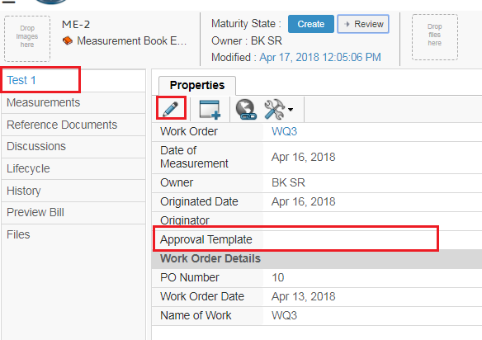

Approval Template if Blank promotion will be fail

Name of measurement , click on it will open property page

1. If we try to Promote without Approval Template , then promotion fail , Click in Enable edit button on action menu . Property page will be visible in Edit mode. Enter Approval Template and Click On Done button.

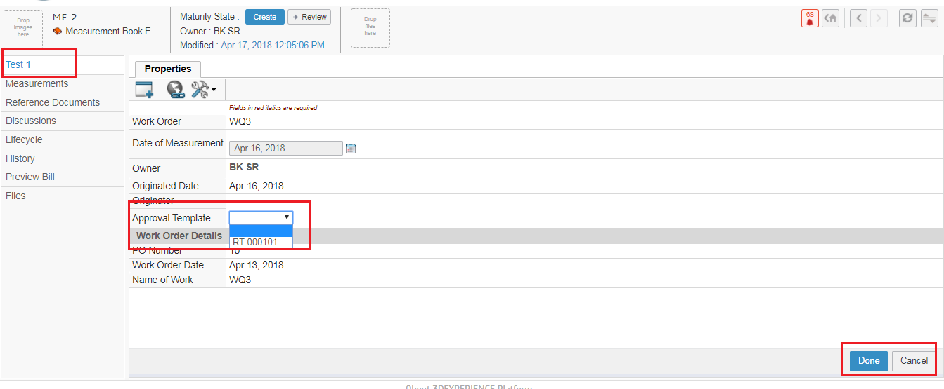

Enter Approval Template

Approval template will be added

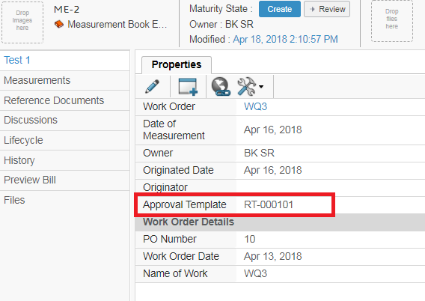

4. From Category menu , click on Lifecycle Lifecycle page will be opened with state **Create Review Submitted**

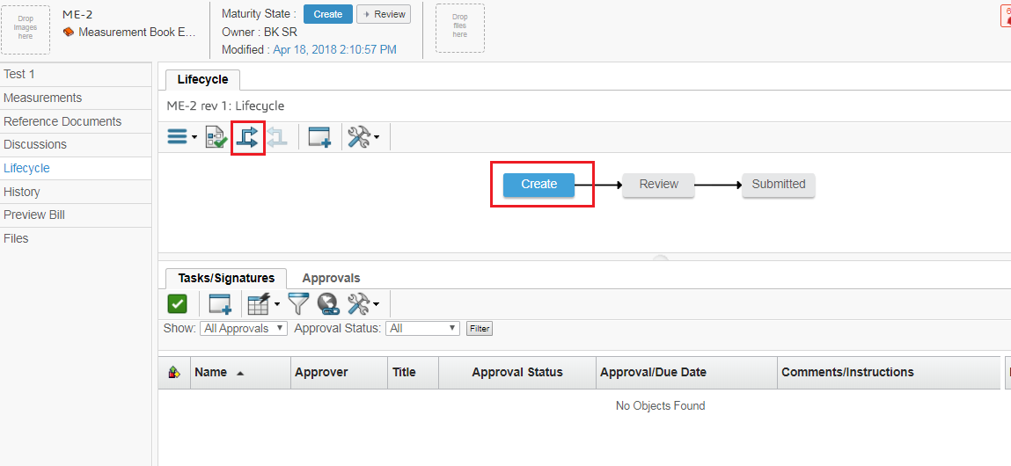

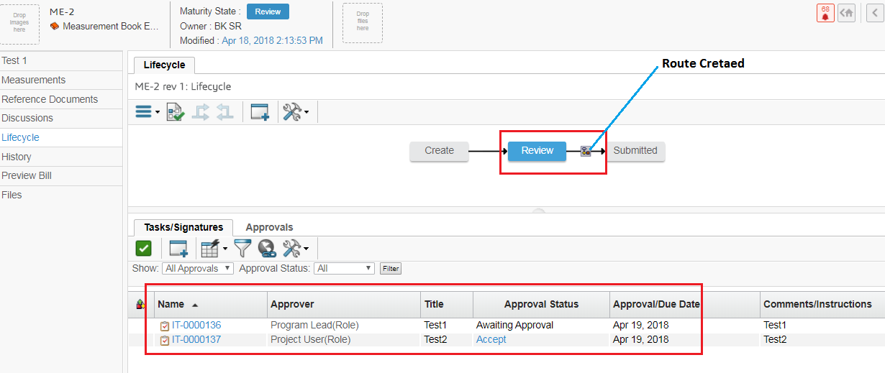

Route created and Promoted to Review State and a notification will send to the Project user for approval

Approval Task created

1. System create a Approval Task ,and a Notification will be send to Category Person with DVM role for Approval.

# 3. Notification Mail

Person with DVM role or (DVM Role)can can see notification sent for measurement entry approval through icon mail .Login Person with DVM role can browse for measurement entries which are waiting for his review/approval

**Login as Person with DVM role with DVM Role**

To check Notification Mail Follow these Steps :-

1. Login to with your user-name and password.

A Mail Notification will be send

2. Navigation : from global Toolbar menu Click on user icon Click on Message

 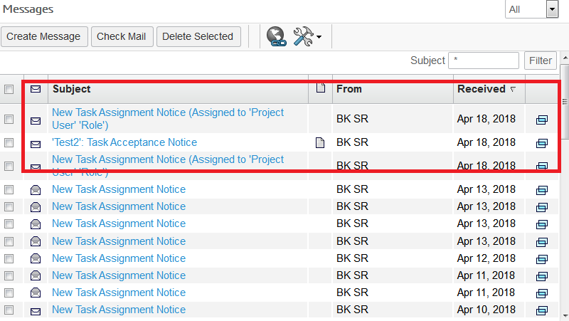

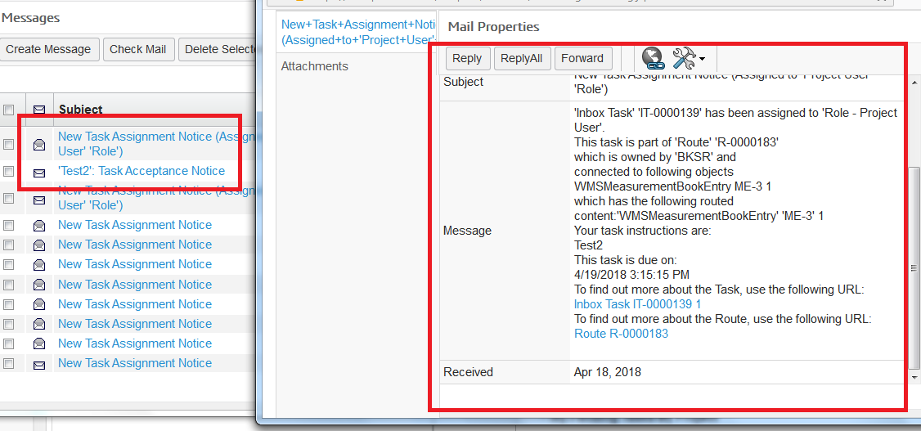

1. Click on The Inbox Task link at the Message filed , there will be link on it.

Which will open Task Properties page .

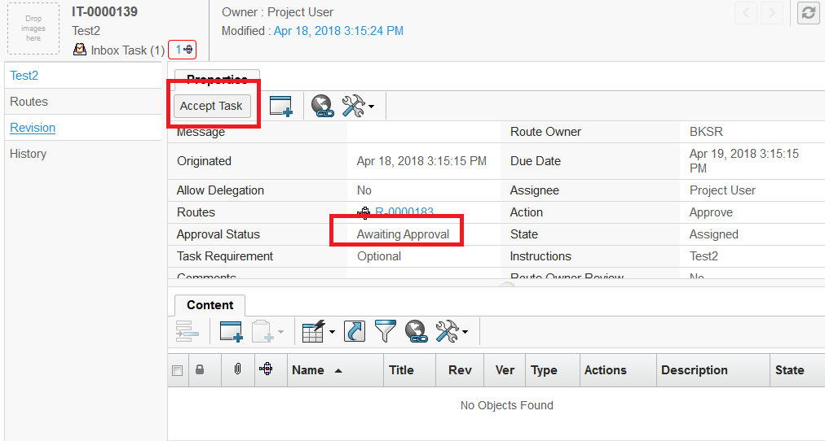

Approval Status will Awaiting as task is not approved

1. From the Action menu click on Accept Task button . As new icon will be visible .

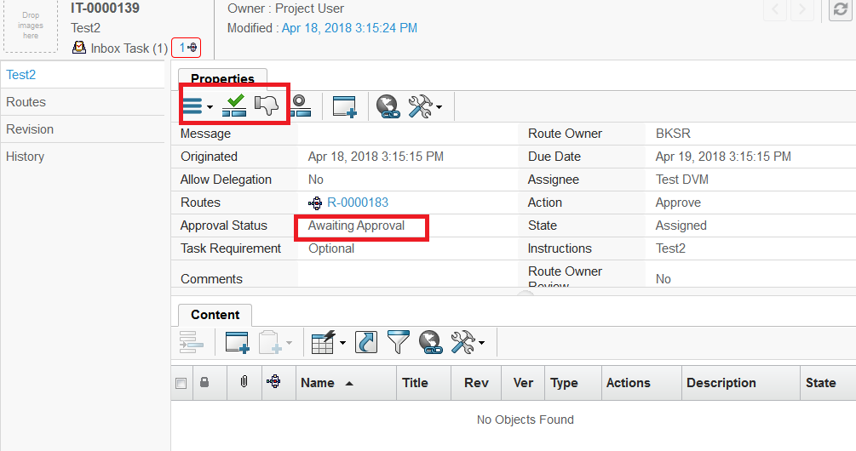

1. Click on Approve Task button from Action menu A Slide In Edit Task Detail Page will open . Enter the Comments and Click on Approve button on Edit Task details page.

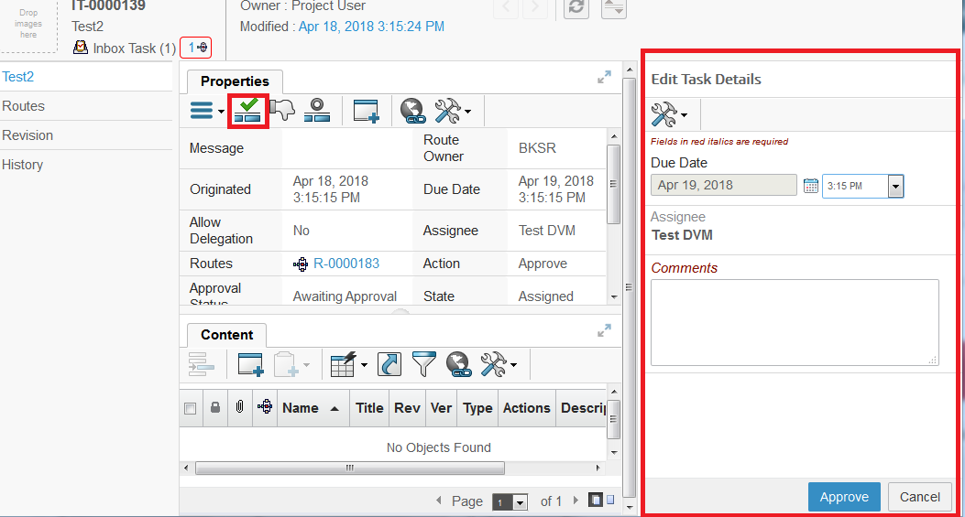

Approve icon , on clicking open Edit Task detail Page

6. Task will approved and a notification will be send to Supplier Representative for Task approval through and the Task will be moved to Submitted state.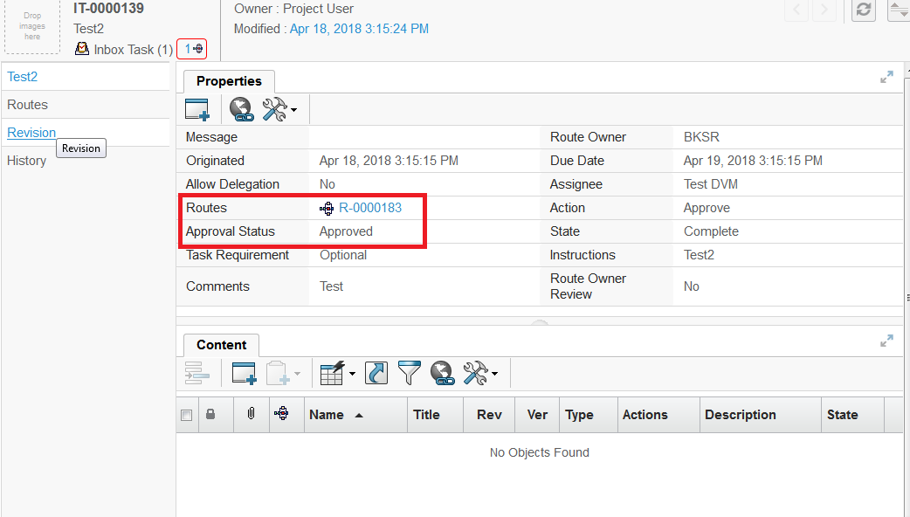

Task will approved

**Login as Person with DVM role with DVM Role**

To check Notification Mail Follow these Steps :-

Login to with your user-name and password.

A Mail Notification will be send

7. Navigation : from global Toolbar menu Click on user icon Click on Message

 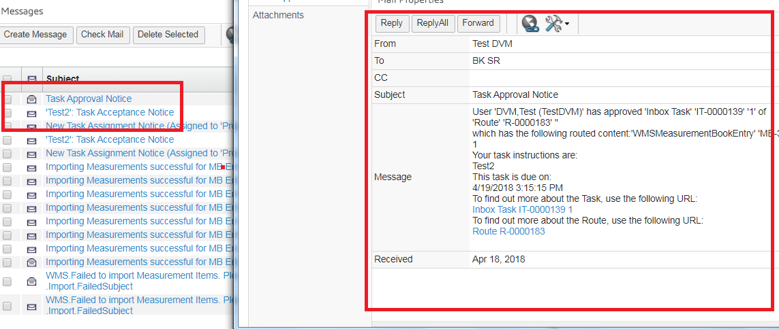

Mail properties page with link on Inbox task , click on link

Check for notification received from Project user(DVM)

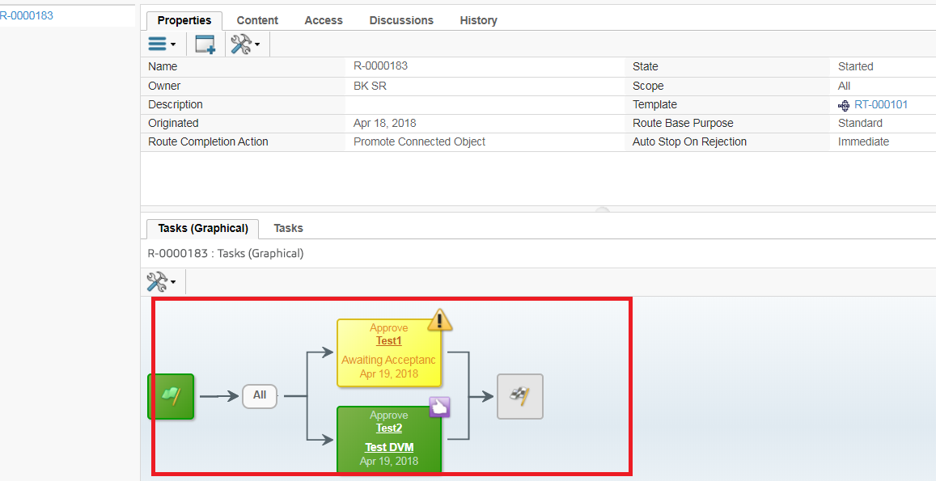

1. Task Graphical page will show that Task will be approved .

# 4. Observe created Measurement Book

As Measurement Book created it is in Create State . Measurement Book at Category menu at Project this will show All the Measurement Book in Which State are , which are under processing

**Login as Supplier Representative**

To Observe Measurement Book state Follow these Steps :-

1. Login to with your user-name and password. Enovia home page appears to user .

2. Navigation :Click on North Quadrant of Compass Project Execution from Category menu click on Measurement Book

 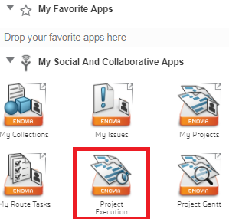

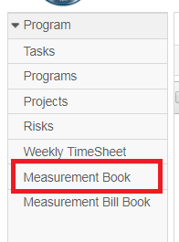

1. Measurement Page will open with 3 different tabs .

A. Work In Progress tab :- All created Measurement which are in create state will shown It here

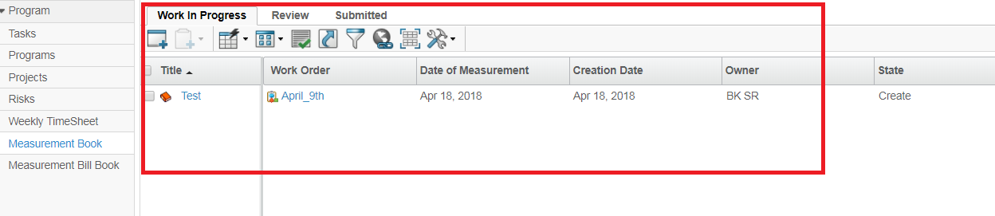

B. Review tab :- Review Tab will have Measurement book which are Promoted to Review State. will be visible at Review Tab

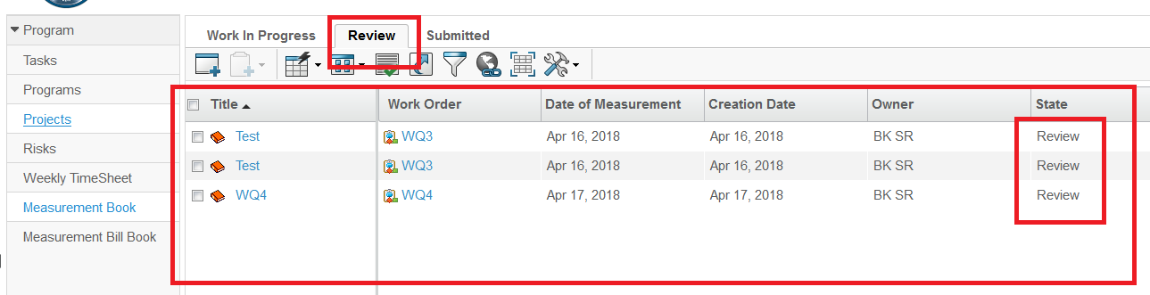

C. Submitted tab :- Tab will have Measurement book which are Promoted to Submitted State. will be visible at Submitted Tab.

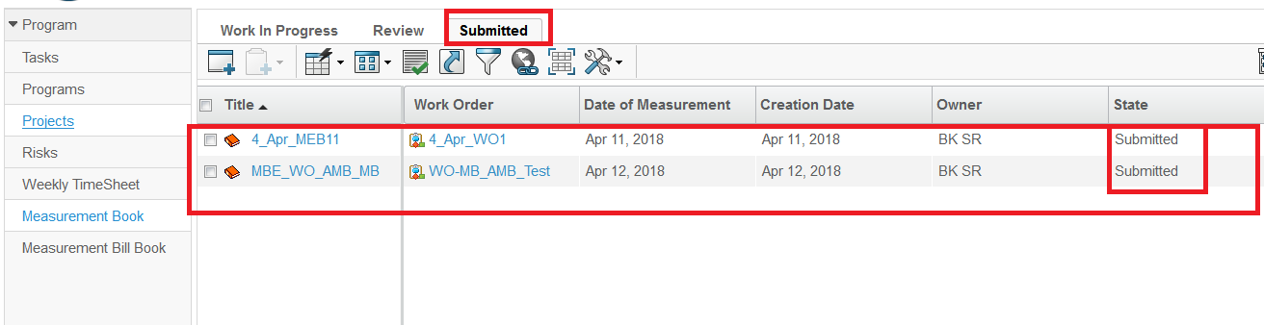

# 5. Reference Document

Reference Document is created or Add Existing at the Measurement Book.

Supplier Representative can add multiple document in Measurement book.

**Login as Supplier Representative**

To Observe Measurement Book state Follow these Steps :-

1. Login to with your user-name and password. Enovia home page appears to user .

2. Measurements page From category menu , Click on Reference Document

3. Reference Document Page will open . Click on Action menu Click on create New Click on Document Step 1of 2 :- Specific Detail page will open

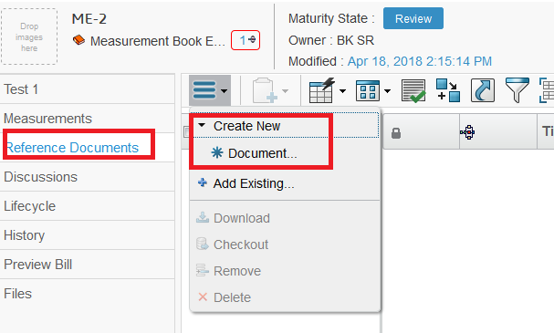

4. Enter All the Detail for Document and Click on Next will

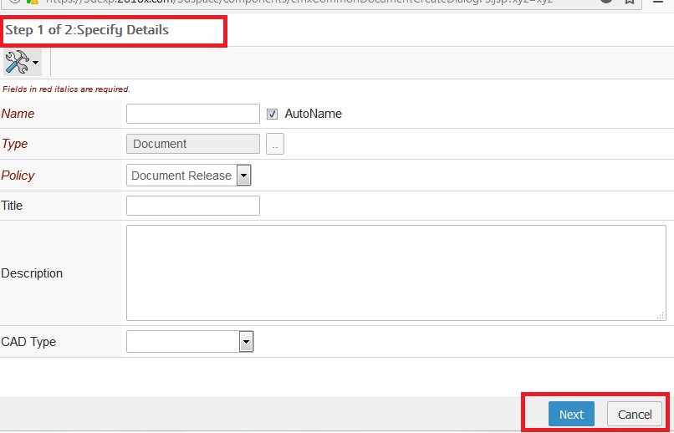

1. Next page will be upload files page and upload files , click on Browse button to upload files , and Click on Done .

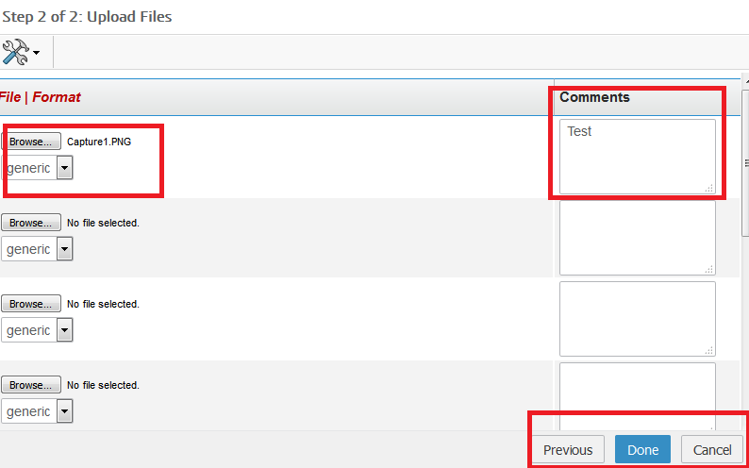

Action column will have download icon, subscription column and checkin icon

Browse button to upload files .

1. Document will be created and display in Reference Document Page.

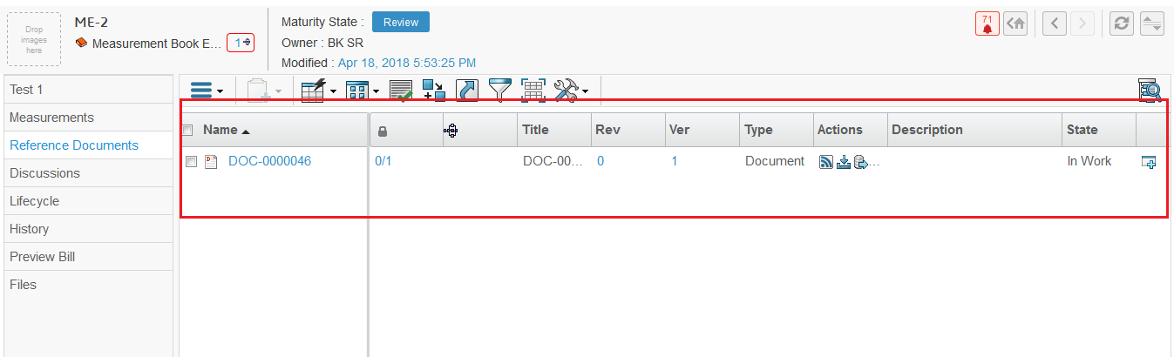

1. Reference Document Page will be opened . Click on Action menu C Click on Add Existing Search Page will open and Select Document from search page and click on Submit Selected Document will be added .

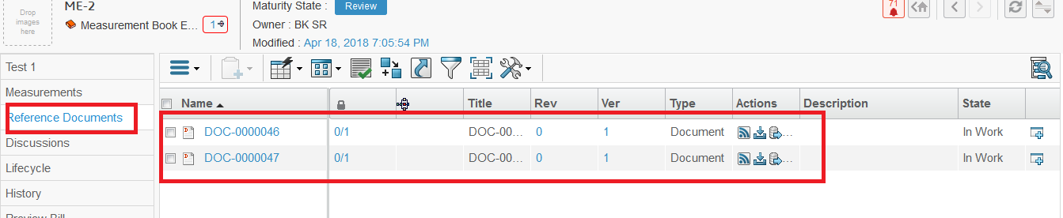

1. Select Document from list Click on Action menu Click on Download

Selected file will be downloaded

1. elect Document from list Click on Action menu Click on Checkout

Selected file will be downloaded for check out

1. Select Document from list Click on Action menu Click on Remove

A pop-up page will be open

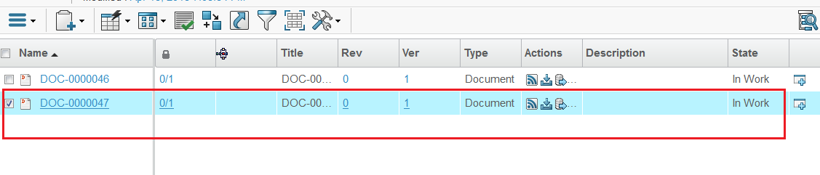

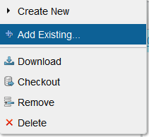

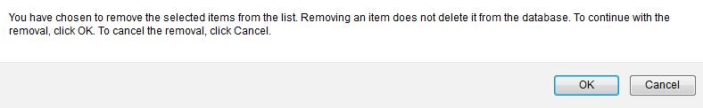

Click on OK , will remove the selected document , and document will be remain in database

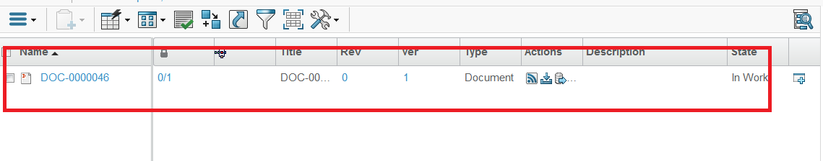

1. Select Document from list Click on Action menu Click on Delete

A pop-up page will be open

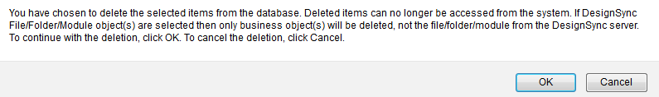

Click on Ok Selected Document will be delete from database permanently.

# 6. Files

When Measurement Book promote to Review State ,file will be added in File Table, .

**Login as Supplier Representative**

To Observe Measurement Book state Follow these Steps :-

1. Login to with your user-name and password. Enovia home page appears to user .

2. Measurements page (when on Review State) . From category menu ,click on Files observe file page

File will be added .

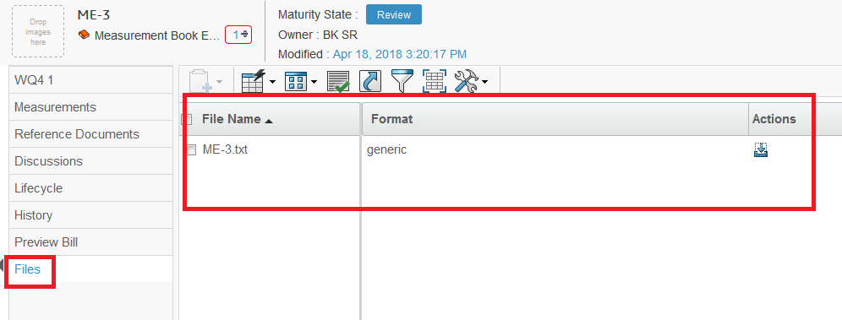

Action icon link will be there to download the files

# ABME (Abstract Measurement Book Entry)

# 1. Create ABME Entry

Regular bills against work done are considered as running bill. For payment of such bills first the measurements needs to be submitted by Supplier Representative with acceptance Person with DVM role, after verification Supplier Representative prepares the bills and forwards for further approvals .

Supplier Representative can raise bill against work order at any time, but only one bill at a time is allowed to be created in system and once it is approved/paid then only next bill is allowed to create.

Abstract bill preparation provides following

**Particulars:** Allows to select and add submitted measurements for billing. Only unbilled measurements are allowed.

**Advance/Recovery:** Adding advances (plant and machinery, mobilization etc), adding recovery of advances in subsequent bills,adding secured advances for material, adding secured recovery with material consumption

**Deductions:** Defining deductions

**Other deductions:** Allows to define taxes and other deduction for billing

**Login as Supplier Representative**

To create Measurement Book Follow these Steps :-

1. Login to with your user-name and password. Enovia home page appears to user .

Navigation :- Click on Capture on global toolbar menu Click on Work Order Management Create Bill

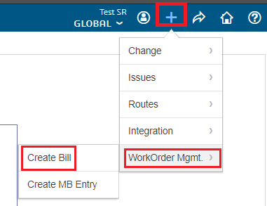

1. Create ABME SlideIn page will open . Enter the Required fields , click on Ok

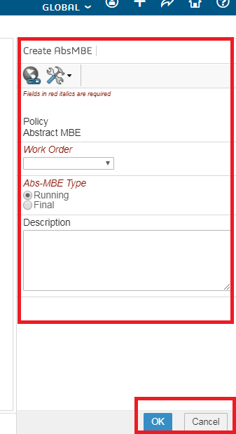 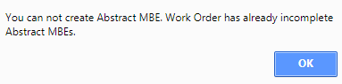

Select work order which are in Active state. (If we have Already created Bill from Work order will throw popup)

1. Abstract Measurement Book will be created .

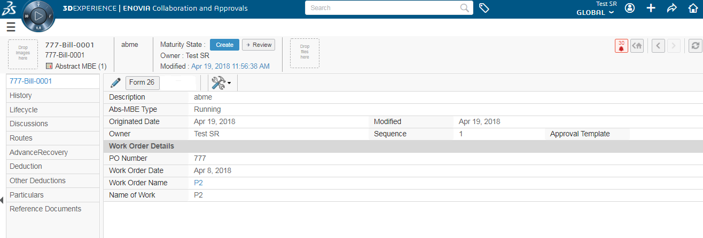

1. For the selected work order abstract bill is created at Create state. System defines work order at work order field . Now Supplier Representative can fill all the relevant sections of the abstract bill.

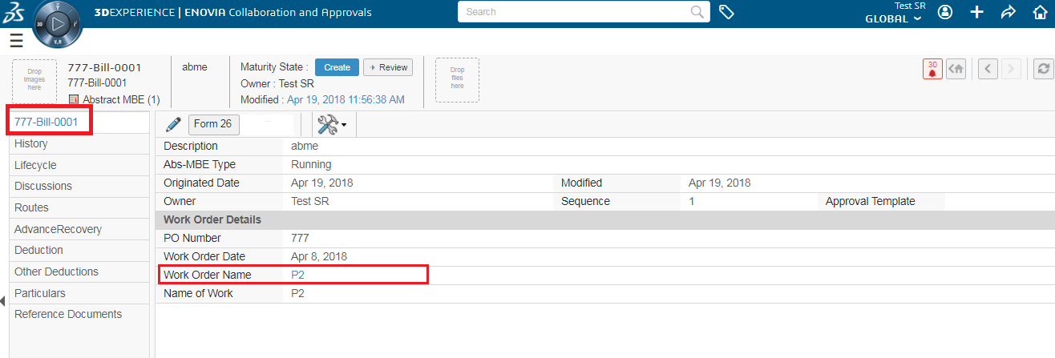

# 2. Particulars

1. Once abstract bill is created, Supplier Representative can add particulars for the bill.

Navigation:- from Abstract MBE page from category menu , click on Particulars

Particulars tab page will be opened by default other 2 tabs are Technical Deduction and Technical Deduction Release .

2. From the Particulars Click on Add Particulars from action menu . Add item page will open which have unbilled submitted and Approve measurement

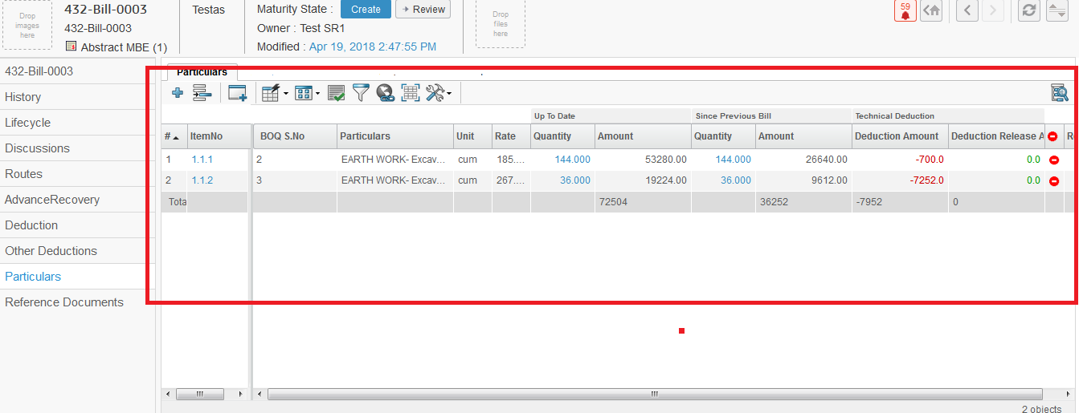

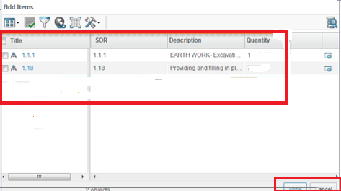

1. Select from Add item page and click on done button , selected particulars will added .

4. SR can check measurement entries under selected item for billing and may remove any if required to make partial selection.



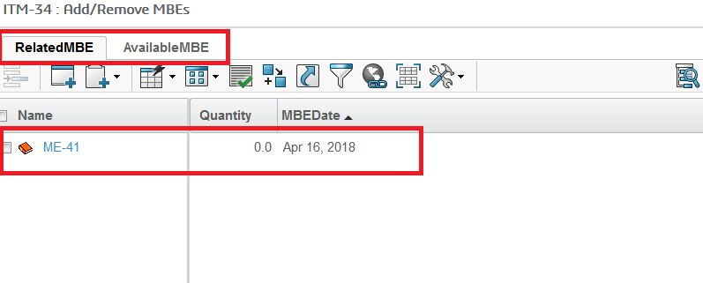

SR can check measurement entries under selected item for billing and may remove any if required to make partial selection.

1. Technical deduction can be applied on items selected under particulars. This can be due to quality issue or some other reason. Provision for technical deduction is based on rate and quantity. Amount can be deducted at reduced rate compared to agreement rate. Also quantity can deducted against the measured quantity. Amount of technical deduction can be flagged as payable later or permanent. Technical deduction with payable later can be paid in subsequent bills, permanent deduction cannot be paid later.

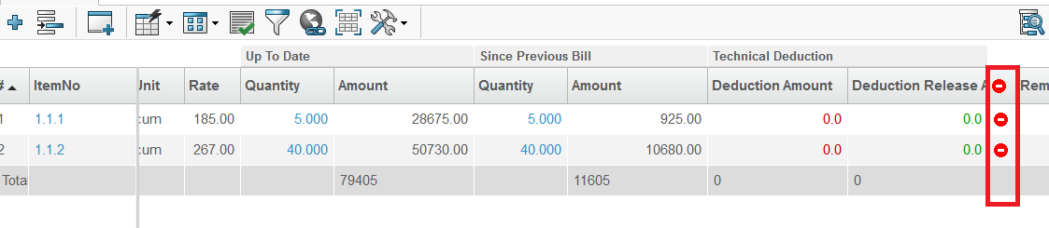

Related Technical Deduction page will open click on Enable edit --> create Technical Detail icon on action menu

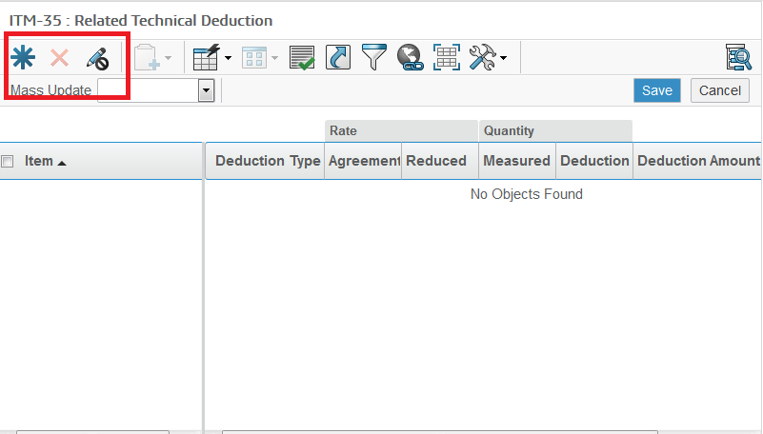

6. After click on create Details icon , a pop-up will be shown click on OK , will create the Technical deduction .

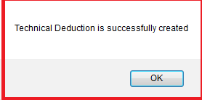

1. Technical Deduction can be added based on rate or quantity. Rate deduction is done with reduced rate payment against measured quantity. And Quantity deduction allows to reduce paid quantity.

Click on save save the deductions

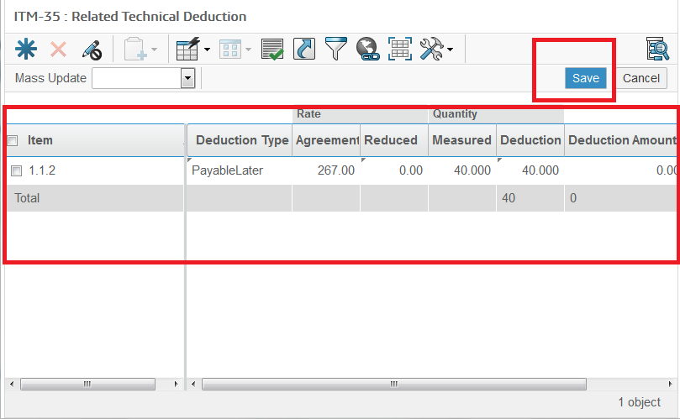

All deduction can be defined as   
Payable Later or Permanents

8. Technical Deduction and technical deduction release tab on particulars

# 3. Advance / Recovery

Mobilization / Plant and Machinery advance can be added under Advance Recovery category of the abstract bill. Supplier Representative can add required particulars.

1. from Abstract MBE page from category menu , click on AdvanceRecovery

Advance / recovery tab will be opened.

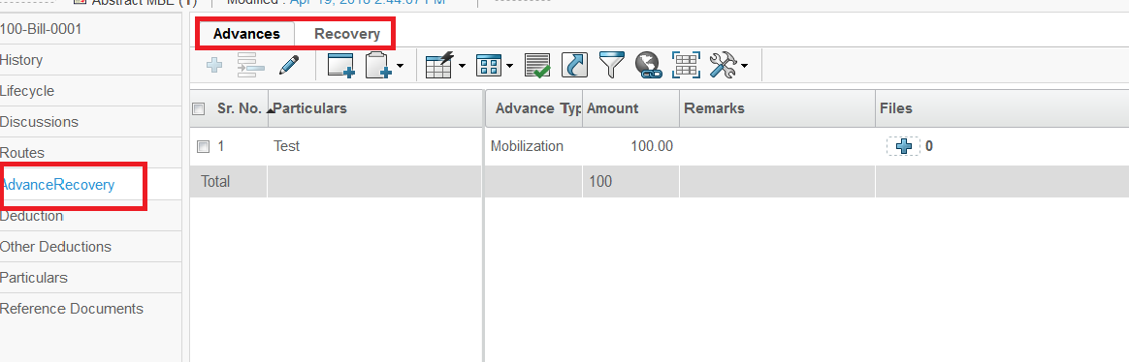

1. From Action menu , click on Enable edit click on Add Advance icon a row will be inserted in edit mode.

Mobilization / Plant and Machinery / Miscellaneous advance can be added under Advance Recovery category of the abstract bill. Supplier Representative can add required particulars.

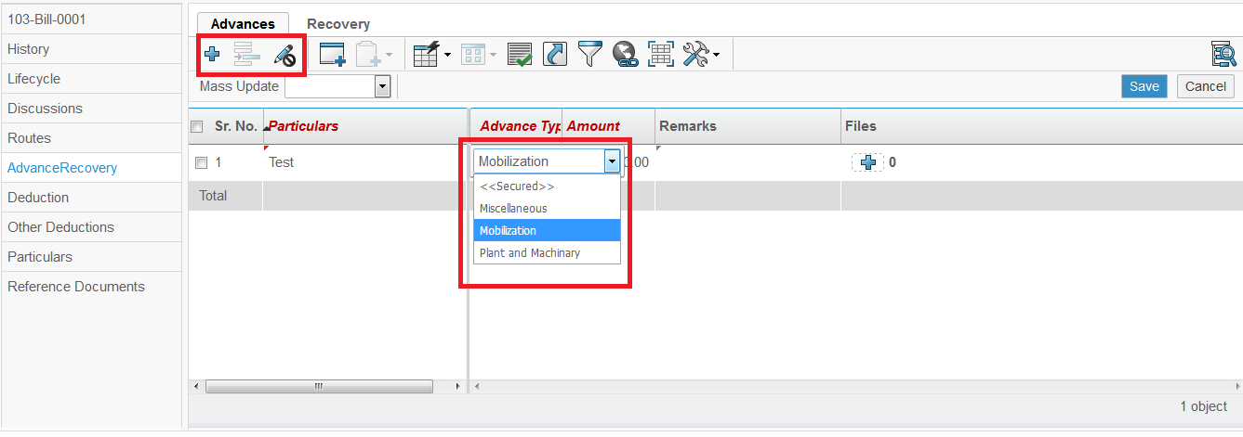

1. Enter all the details and Click on Save . Advance will be added and

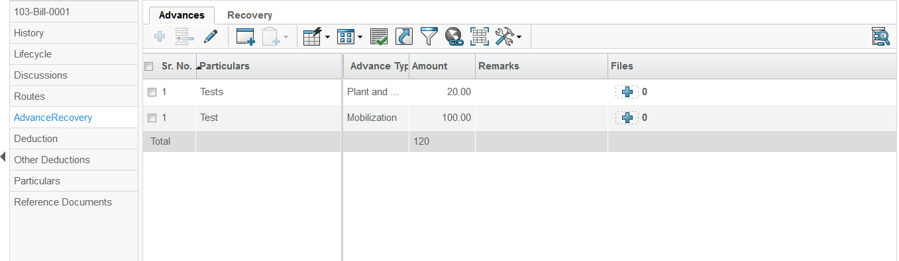

1. Click on the Recovery Tab Recovery page will open Click on Enable edit Click on Add Recovery Icon

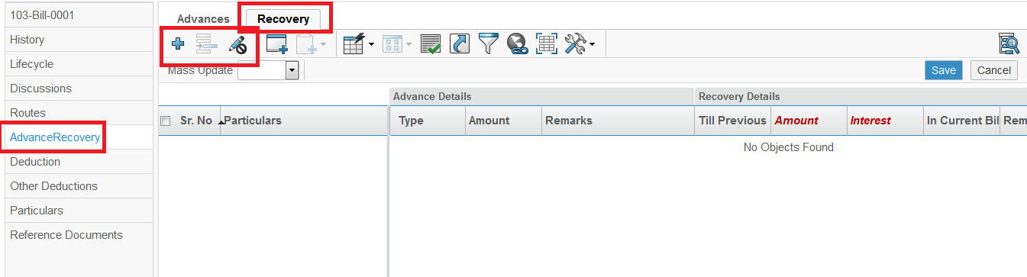

1. Select Add Recovery from the List Click on Submit button. Recovery will added.

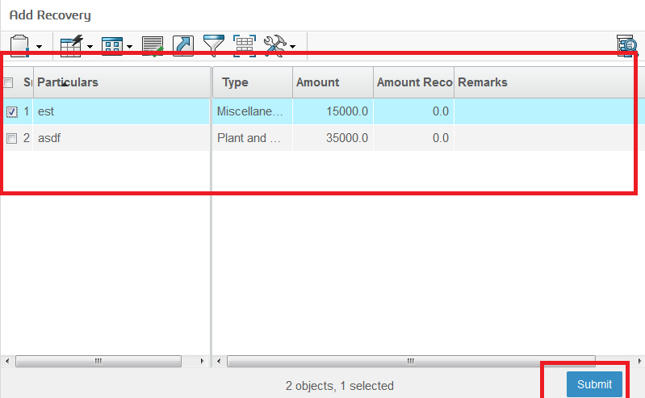

Select Recovery and submit

1. Recovery will be added .

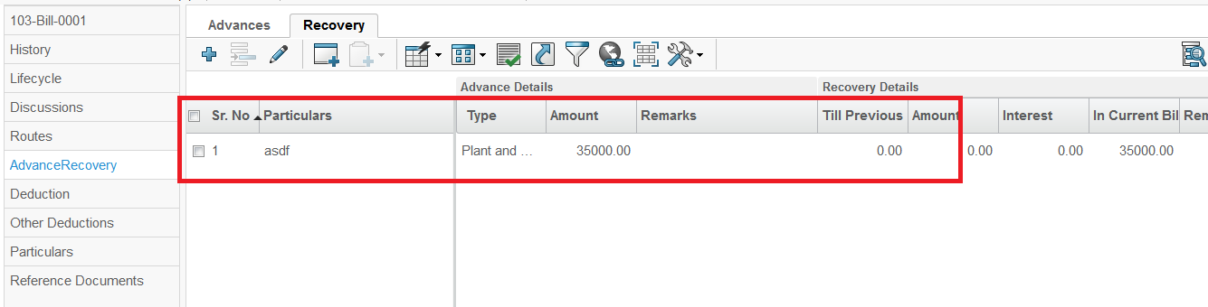

8. Click on Enable Edit . From Action menu table will be in edit Mode Supplier Representative can edit Amount and Interest , by editing amount and Interest current bill changes with respect to changes in amount and Interest column.

9. Click on Save . Edited value will be saved

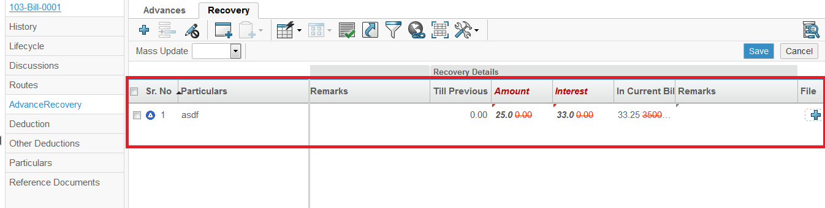

# 4. Deduction (WithHeld / WithHeldRelease)

Supplier Representative can add amount to be withheld with required particulars.Withheld can be payable later or permanent.Permanent withheld deductions cannot be recovered in subsequent bills

1. Navigation :- from Abstract MBE page from category menu , click on Deduction Deduction page will be opened.

Add withheld button click on it to add new row

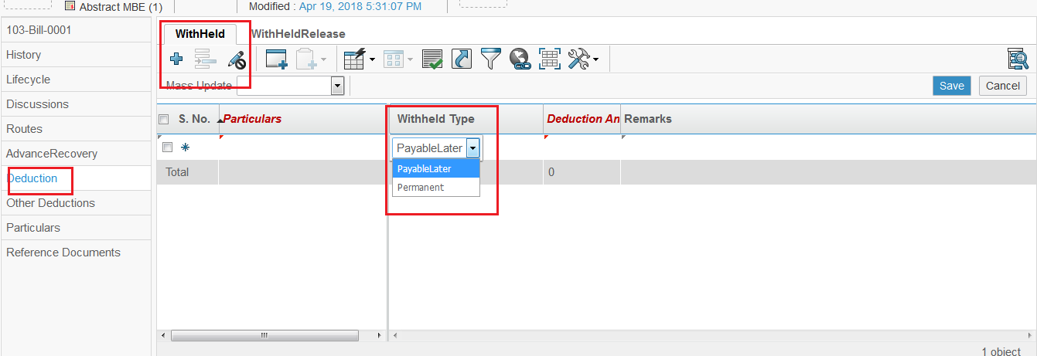

Remove icon will be there to remove withheld

1. Enter Particulars and withheld as Payable late or Permanent from drop down , and click on save button , will save the Withheld .

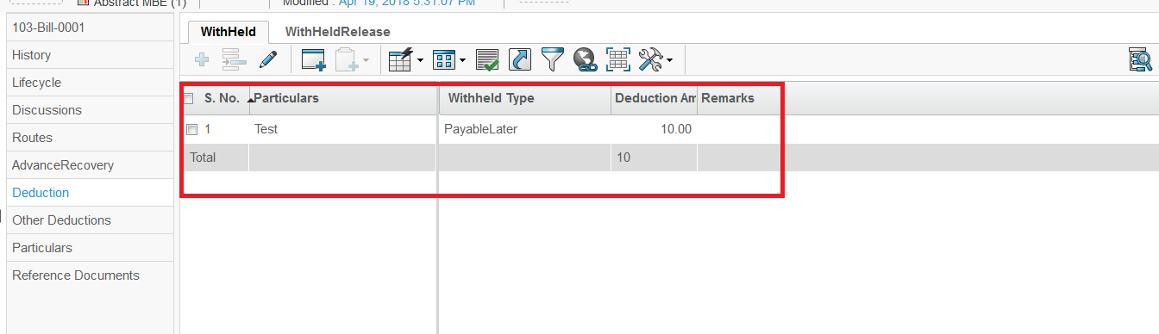

1. Click on WithHeldRelease tab --> with Held Release page will open

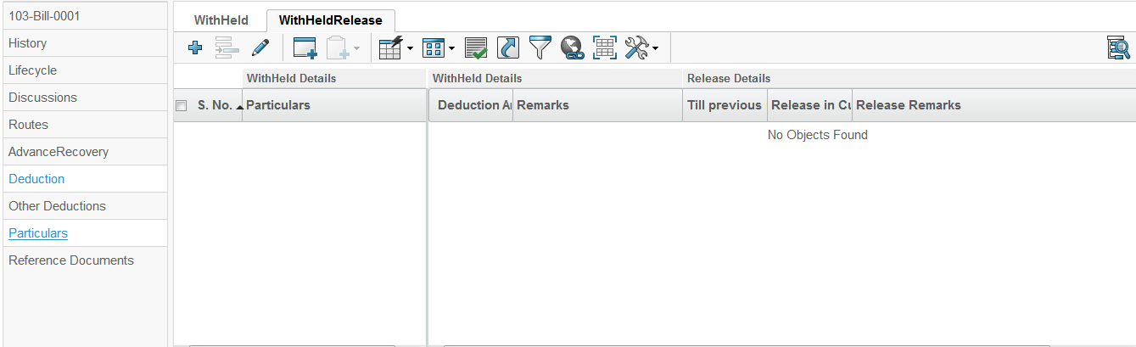

**Field Engineer can click to add previous withheld required particulars.**

**Withheld to be released can be selected if there is already any withheld amount from last bill which is deducted as payable later**

# 5. Other Deduction

Supplier Representative add other applicable deduction to the abstract bill. System provides provision to amount to be deducted from bill .

1. Navigation :- from Abstract MBE page from category menu , click on other Deduction other Deduction page will open

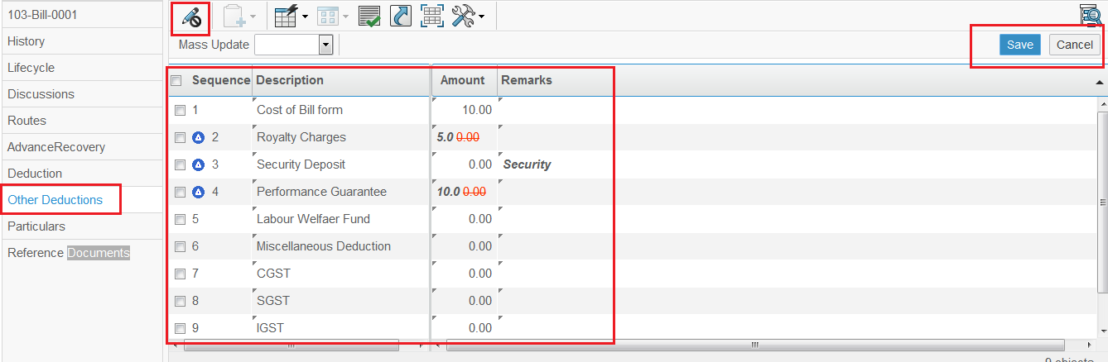

1. Click on Enable Edit , page will be visible in edit mode and Enter the required amount to deduct .
2. Click on Save . Entered data will saved 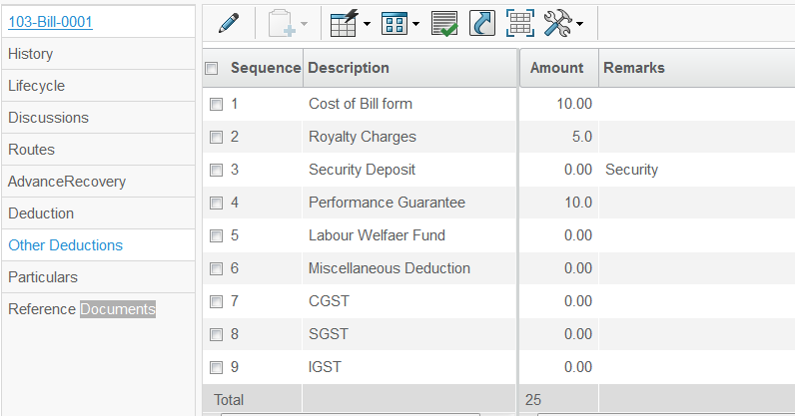

# 6. ABME Approval

Once abstract bill is ready and complete with all necessary inputs, it can be sent for further approval.

Supplier Representative can edit/delete the Abstract measurement entries till those are in Create state . Once Abstract measurement entries are submitted for approval by Person with DVM role . Supplier Representative is not allowed to modify/change any entry . After promoting measurement entry to review, system automatically sends it to reporting Person with DVM role (DVM )for Approval .

After approval on ABME, moves to Submitted state

**Login as Supplier Representative**

To Promote Abstract Measurement bill Book Follow these Steps :-

1. Login to with your user-name and password. Enovia home page appears to user .

2. Navigation :- Abstract Measurement Book entry Page will be openfrom Category Menu Click on name of AbstractME Properties page of ABME will be opened observed the page

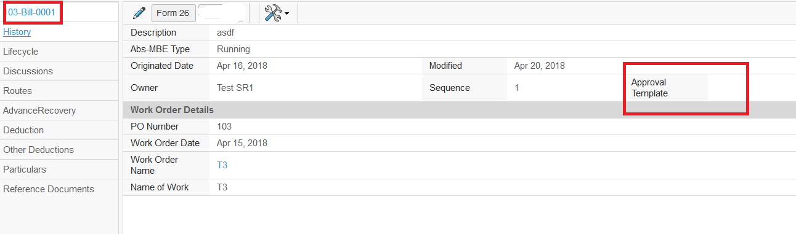

Approval Template is not present so it should not promote as Approval Template must be added here

Click Abstract name here to open property page

3. From the Category Menu click on Lifecycle . Lifecycle page will open with states are

**Create** Review Approve Paid

Try to promote Now . From icon Promote icon on Action menu . It will not promote , as Approval template is not added will show a message

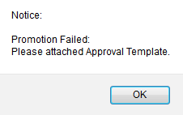

Click on OK as promotion failed and Moved to Abstract bill Property page and click on Enable edit button

1. From the Properties Page click on Enable edit button . All page will be in Edit mode

Add the Approval template and Click on Done button .

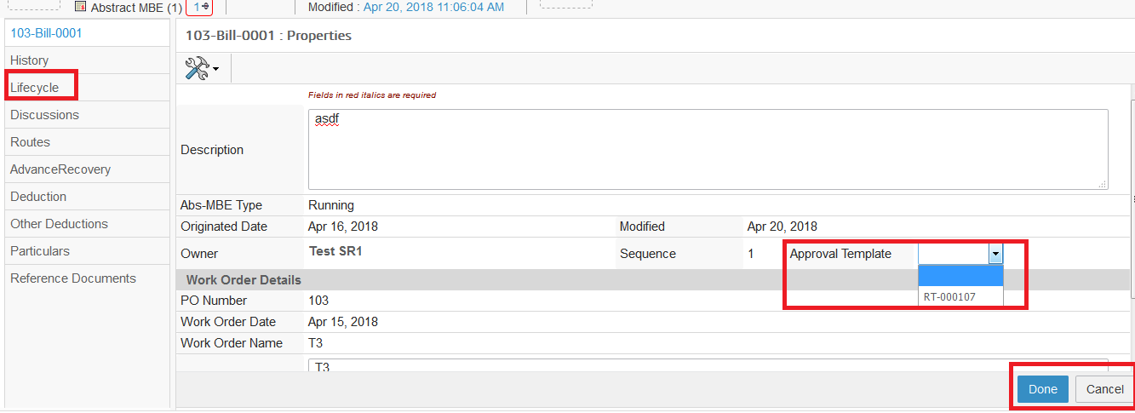

Approval Template Added

1. Approval Template added --> Click on Lifecycle from category menu --> lifecycle page will open --> from Action menu try to Promote.

It Will promote to Review State and a route will be created for Approval.

System create a Approval Task ,and a Notification will be send to Category Person with DVM role for Approval.

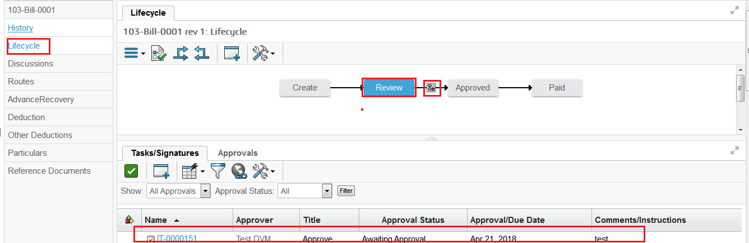

Route and Approval Task created

Moved to Review state

# 7. Notification Mail

Person with DVM role or (DVM Role)can can see notification sent for measurement entry approval through icon mail .Login Person with DVM role can browse for measurement entries which are waiting for his review/approval

**Login as Person with DVM role with DVM Role**

To check Notification Mail Follow these Steps :-

1. Login to with your user-name and password.

A Mail Notification will be send

2. Navigation : from global Toolbar menu Click on user icon Click on Message



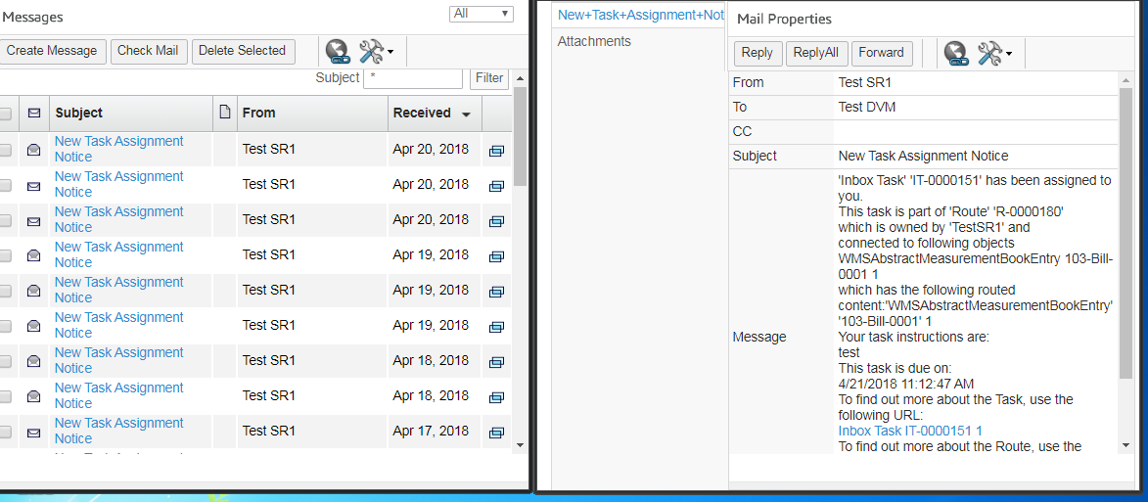

From mail properties page click on Inbox task for approval

3. Task Approval Page will open , from Action Menu click on Approval task icon

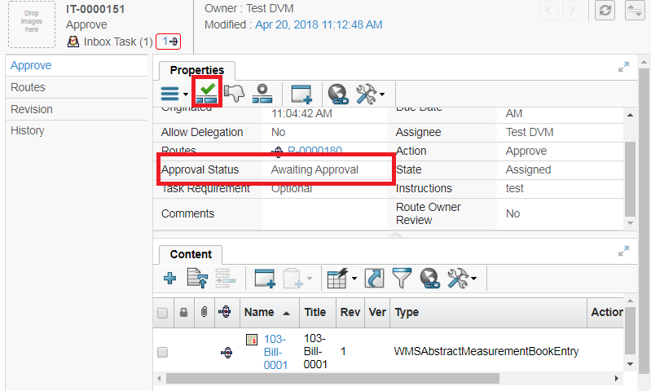

Task status , waiting for approval

Approval Task icon , click onit

1. On Click in Edit Task Detaiils Slide-In page will be opened . -->> Enter the Comment for Approval and --. Click on Approve.

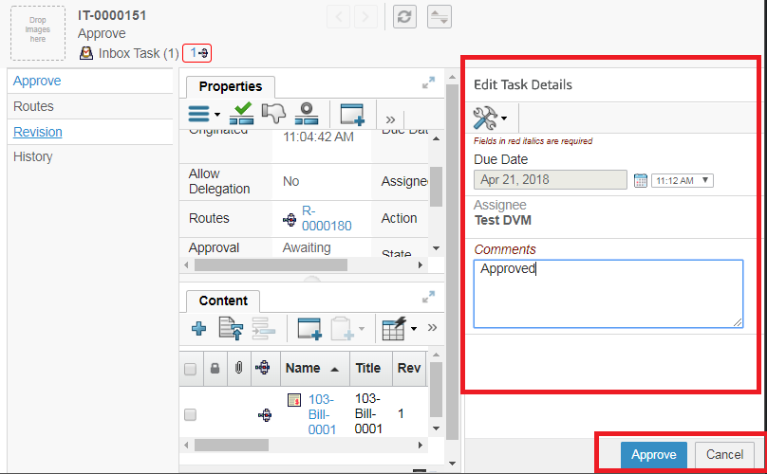

5. A notification will be send to Supplier Representative for Approval.

Task approval will be visible at Properties Page.

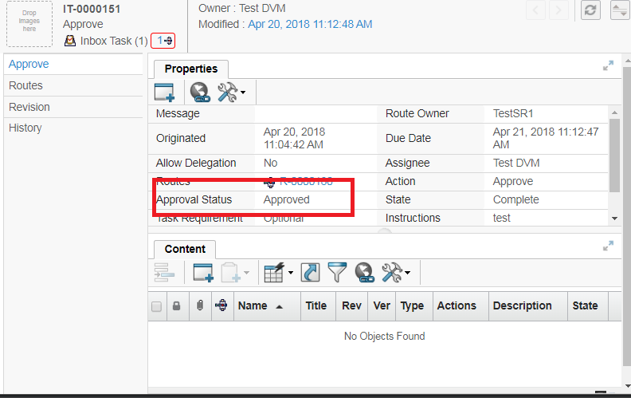

7. Now Login with Supplier Representative . And open the Abstract Bill.

1. Navigation : from global Toolbar menu Click on user icon Click on Message



2. Notification Mail will be received at Supplier for Task Approval

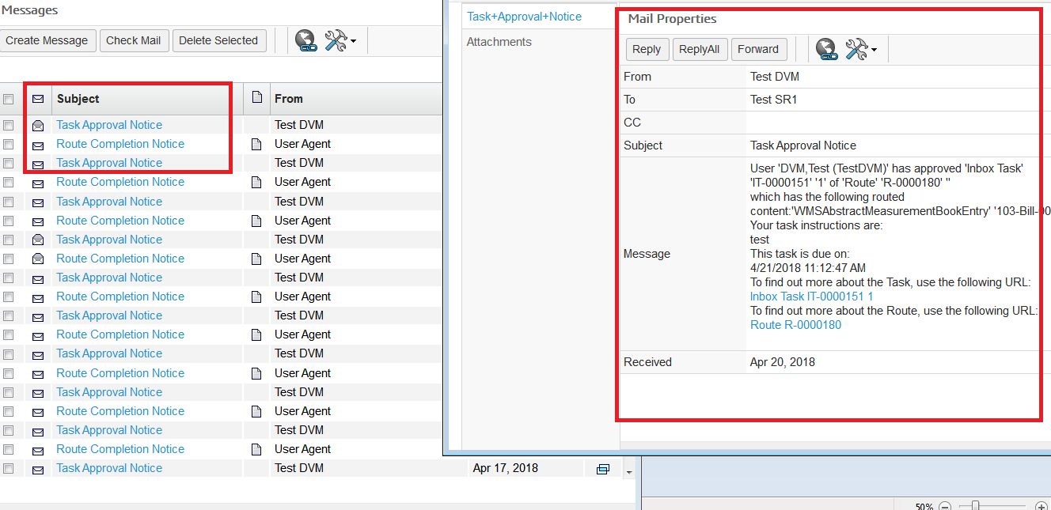

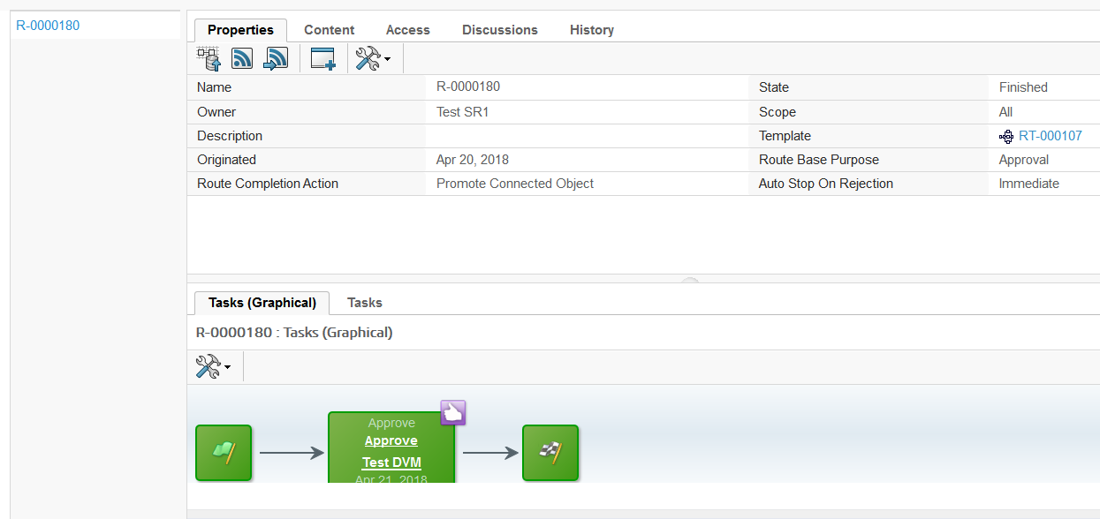

Task will be approved by DVM role

1. Open abstract measurement and (for which getting Notification)--> click on Lifecycle and observe , state will be moved to Approve State

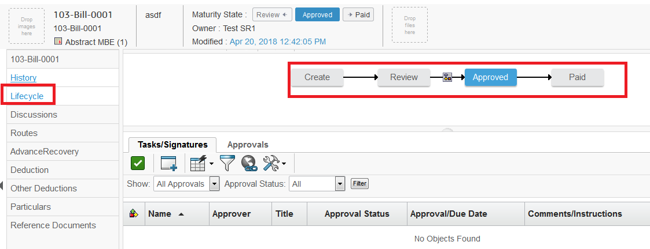

Approved by DVM role and state will moved to Approved state shown

# 8. Reference Document

Reference Document is created or Add Existing at the Abstract Measurement Book.

Supplier Representative can add multiple document in Abstract MBE

**Login as Supplier Representative**

To Observe Measurement Book state Follow these Steps :-

1. Login to with your user-name and password. Enovia home page appears to user .

2. Abstract MBE page From category menu , Click on Reference Document

3. Reference Document Page will open . Click on Action menu Click on create New Click on Document Step 1of 2 :- Specific Detail page will open

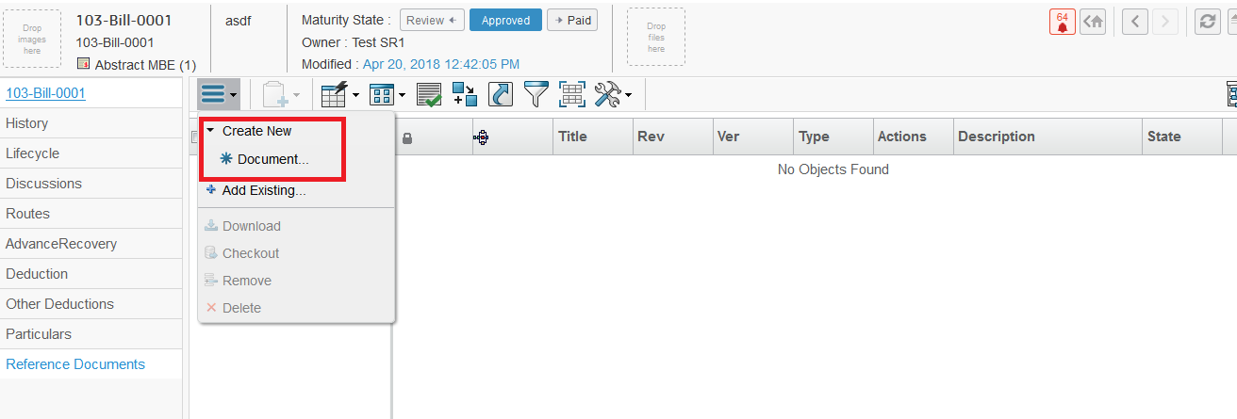

4. Enter All the Detail for Document and Click on Next will



5. Next page will be upload files page and upload files , click on Browse button to upload files , and Click on Done .



Action column will have download icon, subscription column and checkin icon

Browse button to upload files .

6. Document will be created and display in Reference Document Page.

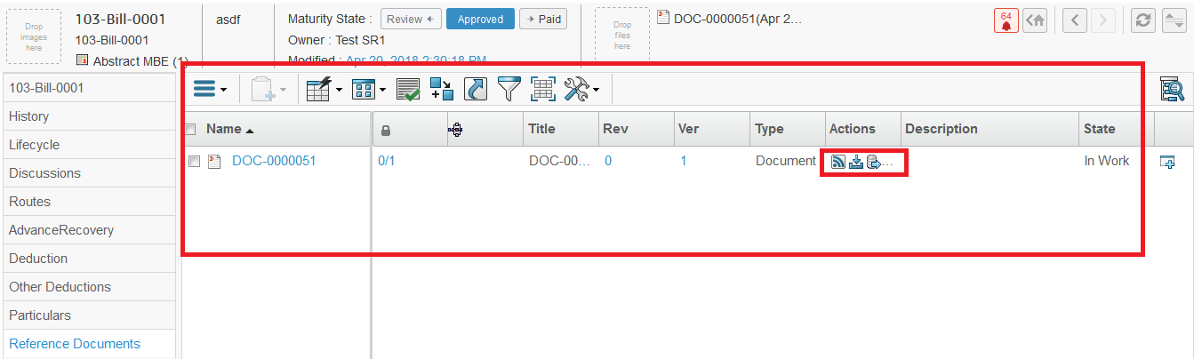

7. Reference Document Page will be opened . Click on Action menu C Click on Add Existing Search Page will open and Select Document from search page and click on Submit Selected Document will be added .

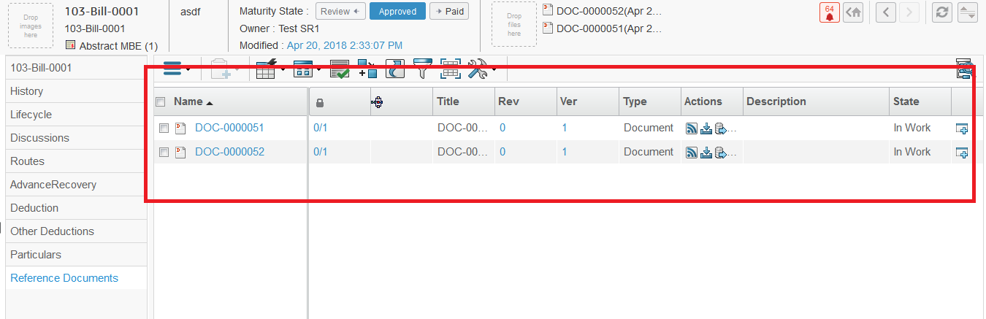

8. Select Document from list Click on Action menu Click on Download

Selected file will be downloaded

9. Select Document from list Click on Action menu Click on Checkout

Selected file will be downloaded for check out

10. Select Document from list Click on Action menu Click on Remove

A pop-up page will be open

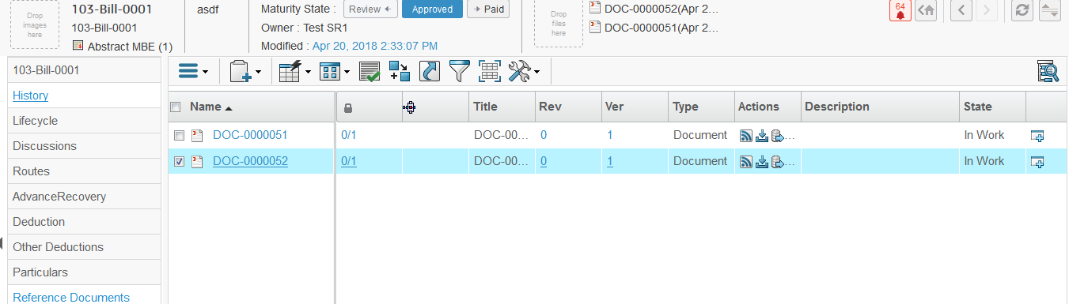





Click on OK , will remove the selected document , and document will be remain in database

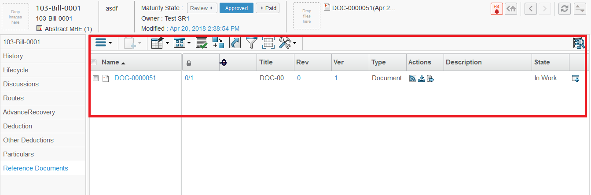

11. Select Document from list Click on Action menu Click on Delete

A pop-up page will be open



Click on OK Selected Document will be delete from database permanently.

# 9. Observe created Abstract MBE

As Abstract MBE created it is in Create State . Abstract MBE at Category menu at Project this will show All the Measurement Book in Which State are , which are under processing .

**Login as Supplier Representative**

To Observe Measurement Book state Follow these Steps :-

1. Login to with your user-name and password. Enovia home page appears to user .

2. Navigation :Click on North Quadrant of Compass Project Execution from Category menu click on Measurement Bill Book

 

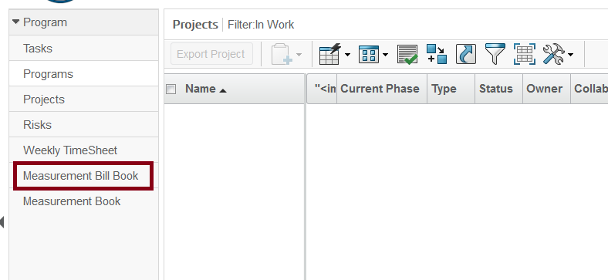

1. Measurement Bill Book Page will open with 3 different tabs .

A. Work In Progress tab :- All created Measurement Bill which are in create state will shown It here

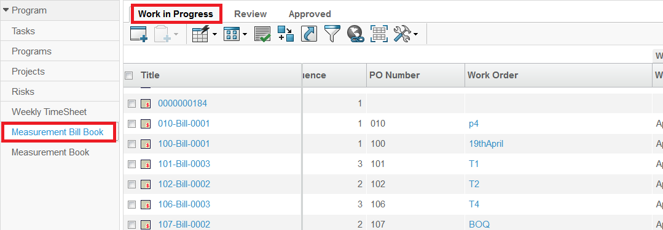

B. Review tab :- Review Tab will have Measurement book which are Promoted to Review State. will be visible at Review Tab

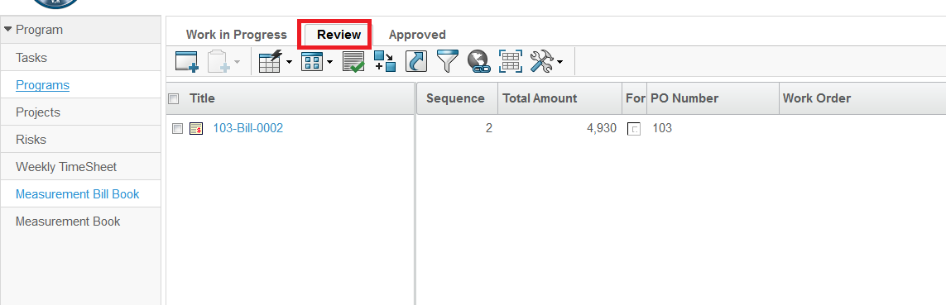

C. Submitted tab :- Tab will have Measurement book which are Promoted to Submitted State. will be visible at Submitted Tab.

